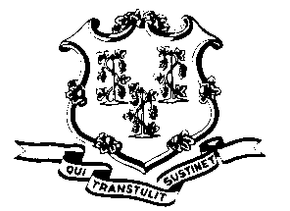
STATE OF CONNECTICUT

OFFICE OF POLICY AND MANAGEMENT

Office of Labor Relations

July 15, 2011

General Notice 2011-15

TO: Labor Relations Designees

SUBJECT: Sample Layoff Notices/Bumpee Letters and Meeting Requirement
Notices:
Attached are Sample Layoff Notices by Bargaining Unit for positions that have been identified for layoff as well as for positions that will be affected by displacement/bumping. As you may recall, on the basis of a 2003 arbitration award, the State no longer issues at risk notices. Accordingly, the attached bumpee letters have been drafted in consideration of this arbitral precedent. As these are sample letters, please review and appropriately tailor to fit your Agency’s specific needs. Please review OLR Gen Notice 2011-13a for issuance of notices related to P-5 and P-4 IT.

Meeting Requirement:
Many of the executive branch bargaining unit contracts contain language that contemplates a meeting/discussion between the Employer and the Union during the layoff notice period. The Office of Labor Relations is in the process of scheduling such meetings centrally with the applicable union representatives. To the extent that you are contacted directly by a union representative in this regard, please notify this office.
Agency Labor Relations Designees with questions may contact the Office of Labor Relations at 418-6447. All other questions should be directed to the agency personnel office.

Linda J. Yelmini
Linda J. Yelmini
Director of Labor Relations

