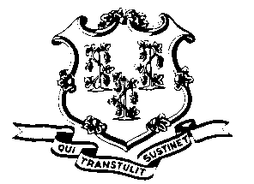
STATE OF CONNECTICUT

OFFICE OF POLICY AND MANAGEMENT

Office of Labor Relations

June 2, 2011

General Notice 2011-11

TO: Labor Relations Designees

SUBJECT: Time off with pay to discuss Tentative SEBAC Agreement

I have been instructed by Secretary of OPM, Ben Barnes for the month of June, 2011, that Commissioners may approve limited time off for bargaining unit members to attend meetings intended to educate them on proposed changes to SEBAC or collective bargaining agreements. Such approvals should be as limited as possible and should not cause significant disruptions to state services. You should report any such approvals to Secretary Barnes’ office. A CORE code will be established to record this time so that proper records can be maintained. You will be informed of the code shortly.

As of July 1, 2011, OLR General Notice 2011-07 will be reinstituted.

Agency Labor Relations Designees with questions may contact Secretary Barnes’ office at 860-418-6500. All others should contact their agency Human Resource office.

Linda J. Yelmini
Linda J. Yelmini
Director of Labor Relations

