STATE OF CONNECTICUT
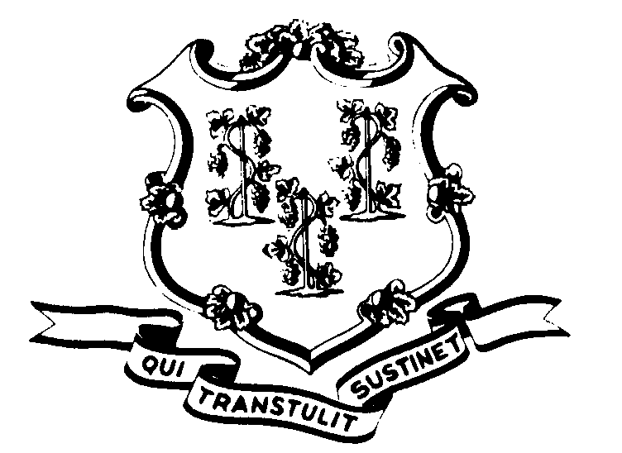

OFFICE OF POLICY AND MANAGEMENT

Office of Labor Relations

September 24, 2008

General Notice 2008-09 (Revising 2004-19)

TO: Labor Relations Designees

SUBJECT: Political Activity

As we approach the election season, you are reminded that the provisions of CGS §5-266a, regulations promulgated thereunder as well as federal law, govern political activities of classified state employees. You can access DAS General Letter No. 214-D, which outlines in detail the provisions governing such activity. (http://www.das.state.ct.us/HR/om/GL214D.pdf)
State employees cannot engage in political activity while being paid by the State of Connecticut. We have recently been asked whether postings on bulletin boards asking for donations to political campaigns are permitted. Such postings would violate CGS §5-266a (a) (2). As such, they should be removed. We have also been asked about whether employees can wear political buttons, clothing, etc. indicating their support of a particular candidate. The wearing of such items would also violate CGS §5-266 (a) (2). Those employees who engage in activities which violate CGS §5-266a would be subject to disciplinary action.
Agency Labor Relations Designees with questions may contact the Office of Labor Relations at 418-6447. All other questions should be directed to the agency personnel office.

Linda J. Yelmini

Linda J. Yelmini
Director of Labor Relations

