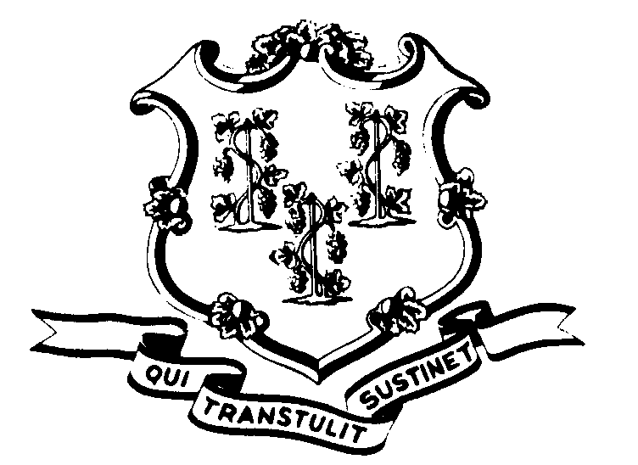STATE OF CONNECTICUT

OFFICE OF POLICY AND MANAGEMENT

Office of Labor Relations

January 17, 2008

General Notice No. 2008-01

TO: Labor Relations Designees

SUBJECT: January 14th Snow Storm

On the morning of January 14, 2007, Governor Rell announced through various media outlets that due to heavy snowfall overnight “all non-essential state employees should use caution and take any extra time needed in reporting to work”. This was NOT a statewide delayed opening. Affected employees may avail themselves of the inclement weather provisions of their collective bargaining agreements as applicable.

Employees are not entitled to additional compensation for reporting to work on time. Employees who were scheduled for vacation, sick or other earned time off shall be charged accordingly.

If employees have any questions about this notice they should be directed to contact their agency Human Resources Office. Any labor relations designees with questions may contact the Office of Labor Relations at 418-6447

Linda J. Yelmini

Linda J. Yelmini
Director of Labor Relations

