STATE OF CONNECTICUT
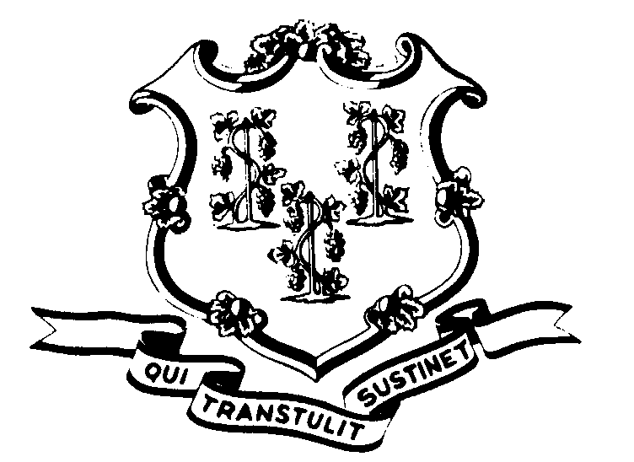

OFFICE OF POLICY AND MANAGEMENT

Office of Labor Relations

June 29, 2007

OLR General Notice 2007-13

TO: Labor Relations Designees

SUBJECT: Memorandum of Agreement – Information Technology Job Classifications

Attached is a copy of the Memorandum of Agreement which was negotiated regarding changes to the Information Technology job classifications and compensation levels, together with a schedule indicating the parties agreement regarding the placement of individuals in particular job classifications. As the Agreement is effective July 6, 2007, kindly take all necessary steps to implement the terms of the same.

All exam announcements will be removed from the DAS website effective today's date, June 29, 2007. Current certification lists and current IT Job Codes will be ineffective as of July 6, 2007.

Labor Relations Designees with questions concerning this General Notice should contact Diane Fitzpatrick at 418-6447 with labor relations questions, Michele Fournier at 713-5254 with DAS classification issues and Michelle Burns at 713-5254 with questions on examination issues. All others should contact their Central Personnel Office.

Robert L. Curtis
Robert L. Curtis
Director of Labor Relations

