STATE OF CONNECTICUT
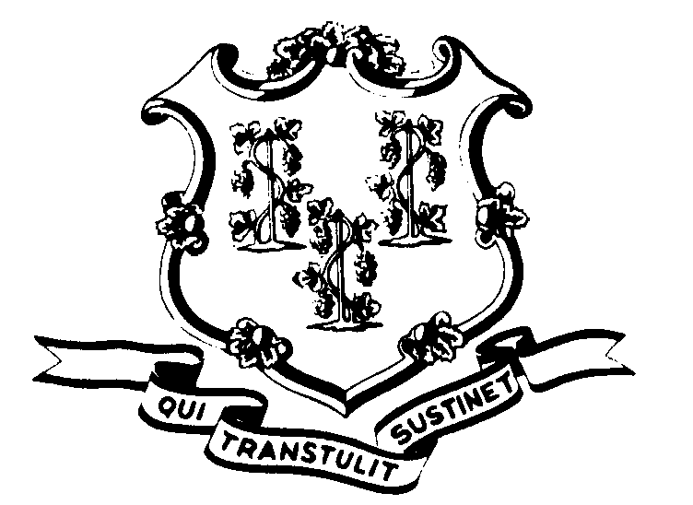

OFFICE OF POLICY AND MANAGEMENT

Office of Labor Relations

March 23, 2007

General Notice No. 2007-05

TO: Labor Relations Designees

SUBJECT: March 16, 2007 Snow Storm
On Friday, March 16, 2007, Governor Rell authorized the early release of non-essential State employees. This early release started at 1:30 p.m. due to the weather which caused difficult driving conditions.
Consistent with past practice, contractual and statutory provisions, you are reminded of the following:
- Non-essential employees working on March 16, 2007 who were released early (1:30 p.m. being the earliest) are to be coded “LWGOV” for the hours following departure from work through the end of the employees scheduled work day. Essential employees who were not released early will be paid in accordance with contractual and statutory provisions.
- Employees who were not scheduled to work March 16, 2007 or who did not come to work or departed prior to 1:30 p.m. are not covered by the Governor’s action.
- Employees absent because of illness, scheduled vacation, personal leave, or other earned time shall have the appropriate leave balance charged and are not eligible for “LWGOV” time. Employees on a leave of absence without pay, scheduled day off or pass day shall not be eligible for “LWGOV” time.
- It is understood that the Governor’s action impacted State employees who work on day shift operations and the 2nd and 3rd shift operations were not closed nor were they delayed in opening.
Employee questions about this notice should be addressed to the Agency’s Human Resources office. Agency Labor Relations Designees with questions may contact the Office of Labor Relations at 418-6447.

Robert Curtis

Robert Curtis
Director of Labor Relations

