STATE OF CONNECTICUT
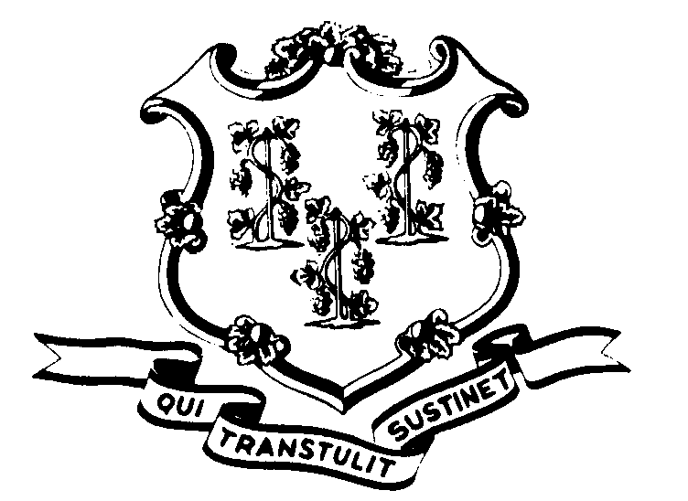

OFFICE OF POLICY AND MANAGEMENT

Office of Labor Relations

July 27, 2006

General Notice No. 2006-19

TO: Labor Relations Designees

SUBJECT: NP-6/P-1 Rotating Shifts Information Request
During the negotiations with District 1199 for successor collective bargaining agreement, the Union raised concerns about the continued existence of “rotating shifts” notwithstanding the contractual prohibition against them. In order to address this concern, we entered into a Memorandum of Understanding (#21 Regarding Rotating Shifts) with the Union to (1) ascertain where rotating shifts may currently be in place and (2) meet and discuss the issue locally (through Labor/Management meetings) with a goal toward elimination of rotating shifts.

The following information needs to be provided to the Office of Labor Relations:
1. Where such shifts may exist in your Agency, including a description of the rotation, e.g. Monday, Wednesday and Friday on the day shift and Tuesday and Thursday on the evening shift.
2. The names, work locations, and classifications of all employees in the NP-6 and P-1 Bargaining Units working said shifts.

This data needs to be provided by September 27, 2006. Please forward information to Fae Brown-Brewton via email at Sandra.Brown-Brewton@po.state.ct.us or via fax at 418-6491.

After we compile this information, we will share it with the Union. Where rotating shifts exist, we will contact you to arrange meetings with local management to determine how we can address this situation.

If you should have any questions, please do not hesitate to contact Fae Brown-Brewton at 418-6217. Employees with questions should contact their Agency Personnel Office.

Robert L. Curtis
Robert L. Curtis
Director of Labor Relations

