STATE OF CONNECTICUT
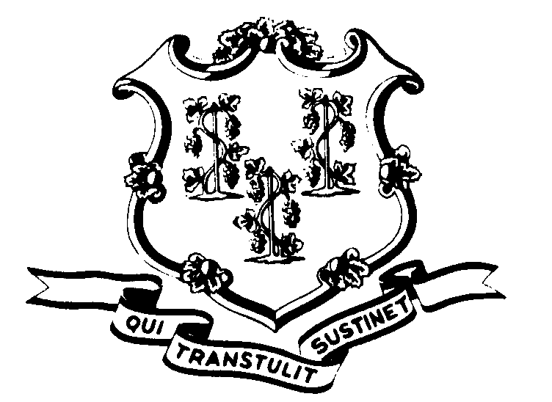

OFFICE OF POLICY AND MANAGEMENT

Office of Labor Relations

November 19, 2004

General Notice No. 2004-21

TO: Labor Relations Designees

SUBJECT: Notice Regarding Stipulated Award

The A&R Union recently pursued a grievance to arbitration concerning layoff notices that were issued to members of the P-5 bargaining unit, but not provided to the Union as required by the contract. With the passage of time, the only issue that remained was that the Union did not have a list of the P-5 bargaining unit members whose employment was separated due to the layoffs. The State and the Union agreed to resolve the matter by providing the Union with a list of the names of those employees in the P-5 bargaining unit who were actually laid off (i.e. lost their jobs) during late 2002 and early 2003.

Please gather this information within the next 15 days so that it can be submitted to the Union consistent with the Agreement reached at arbitration. The information should be forwarded to Fae Brown-Brewton via email at Sandra.Brown-Brewton@po.state.ct.us or via fax at 418-6491.

Your prompt attention to this matter is appreciated.

If you should have any questions, please do not hesitate to contact the Fae Brown-Brewton at 418-6217. Employees with questions should contact their Agency Personnel Office.

Linda J. Yelmini

Linda J. Yelmini
Director of Labor Relations

