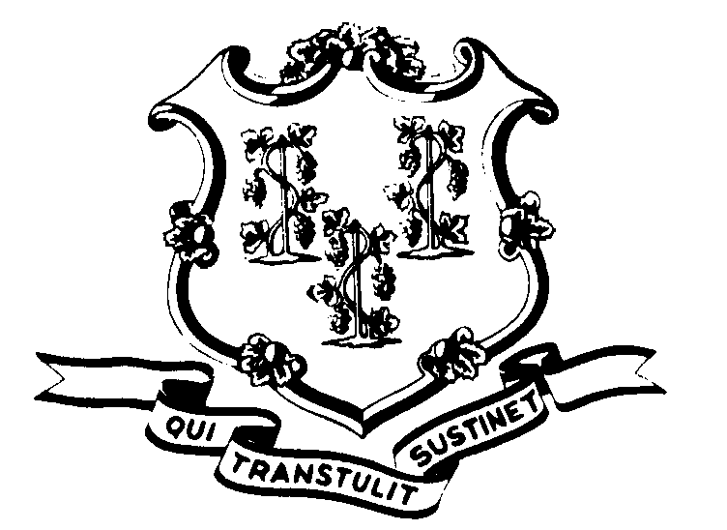STATE OF CONNECTICUT

OFFICE OF POLICY AND MANAGEMENT

Office of Labor Relations

July 21, 2004

General Notice No. 2004-17

TO: Labor Relations Designees

SUBJECT: Executive Order No. 1

As you may be aware, pursuant to CGS §1-83(a), the Governor has expanded the list of those required to file a statement of financial interest with the State Ethics Commission. Governor M. Jodi Rell has expanded the list of required filers to include all State employees who “have responsibility for the review, award or monitoring of state contracts”. Agency heads have been sent the attached guidelines from Rachel Rubin, Special Counsel for Ethics, Office of the Governor.
Pursuant to the Memorandum, Executive Department agencies were instructed to submit to the Ethics Commission a list designating those employees subject to the requirement by July 20, 2004. The Ethics Commission will contact those individuals with instructions on how to file. Newly designated employees must file by August 1, 2004 for the calendar year that ended December 31, 2003. Thereafter, all designated employees will be required to file on an annual basis by May 1st, in accordance with the State Ethics Commission guidelines.
Unions that represent state employees in Executive Department agencies will be informed that this may impact some of their members. Once your agency has submitted the list, it would be advisable to meet with the newly designated employees to inform them and answer any questions they may have.

Employees with questions should contact their Agency Personnel Office.

Linda J. Yelmini

Linda J. Yelmini
Director of Labor Relations

