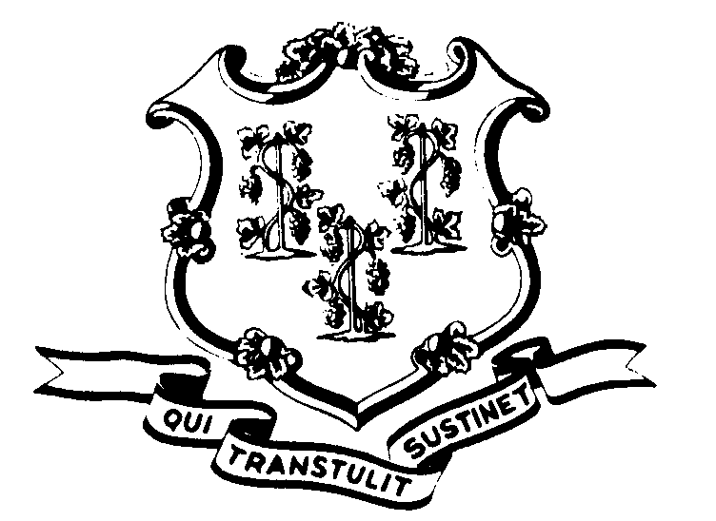STATE OF CONNECTICUT

OFFICE OF POLICY AND MANAGEMENT

Office of Labor Relations

April 14, 2004

General Notice No. 2004-10

TO: Labor Relations Designees

SUBJECT: NP-2 Contract Error (Article 53, Snow and Ice Premium Pay)

Article 53 in the current (2002 – 2005) NP-2 Contract contains an error. The first paragraph should have contained a limitation on receipt of the premium to each hour actually worked other than during the regular shift schedule. The emphasized language was not included in the printed contract, but was a part of the award from the interest arbitration.

Article 53 should read as follows:

Bargaining unit employees designated by the employer as having a snow and ice control or removal assignment shall be paid a premium of one dollar and forty cents ($1.40) for each hour actually worked on snow and ice control or removal, other than during the regular shift schedule.

Premium pay will be authorized under the above conditions from November 1 through April 30 of each year for the life of the contract.

This premium pay will not be used in computing overtime payment.

Because the printed language made it appear that employees were to receive the premium for all hours worked, whether outside the regular schedule or not, it is presumed that some employees may have been overpaid as a result. Agencies must take all appropriate steps to recoup the overpayment following standard procedures.

Questions from Agency Personnel Officers should be addressed to Paul Bodenhofer at 860-418-6215. All others please direct your inquiries to your agency personnel office.

Linda J. Yelmini
Linda J. Yelmini
Director of Labor Relations

