STATE OF CONNECTICUT
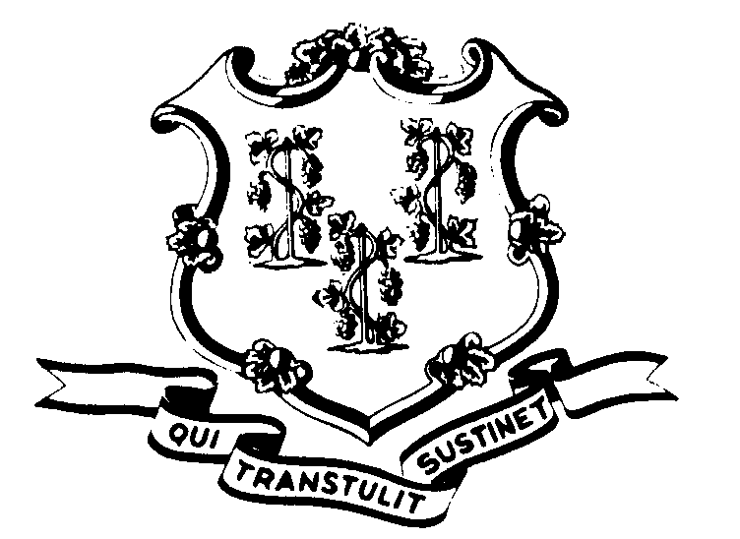

OFFICE OF POLICY AND MANAGEMENT

Office of Labor Relations

July 25, 2003

General Notice No. 2003-22

TO: Labor Relations Designees

Subject: Mandatory Overtime District 1199 Members
Arbitrator Roberta Golick has issued an arbitration award on the subject of mandatory overtime for full-time employees. This was a District 1199 arbitration over the application of Article 13, Section 13 (A). This article and section defines the conditions when mandatory overtime may be utilized: weather emergency; event where the Governor closes state offices; lockdown in Corrections; when the actual staff reporting to work is below minimum safe levels or legal requirements.

This award reverses an earlier determination not to pay double-time to full-time employees until they exceeded a threshold of forty (40) hours of work. Arbitrator Golick has determined that mandated overtime is experienced when the mandatory condition is imposed beyond the employee’s regular shift, without regard to the forty (40) hour threshold.

The Award requires:
- All affected full-time employees are to be compensated at double their hourly rate for all hours worked as mandatory overtime as defined in Article 13, Section 13 (A).
- Those employees from whom prior alleged overpayments were recouped (as a result of the prior determination) shall have the monies returned.

Agencies should immediately implement the provisions of this award.

Labor Relations Designees with questions should contact Robert L. Curtis (418-6241). All others should contact their Central Personnel Office.

Linda J. Yelmini

Linda J. Yelmini
Director of Labor Relations

