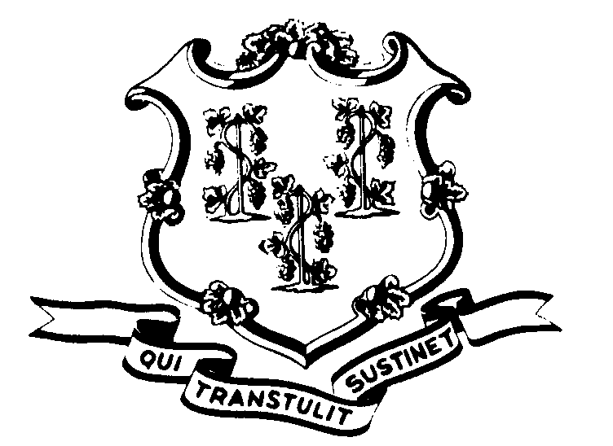STATE OF CONNECTICUT

OFFICE OF POLICY AND MANAGEMENT

Office of Labor Relations

May 14, 2003

OFFICE OF LABOR RELATIONS

GENERAL NOTICE NO. 2003-16B

TO: Labor Relations Designees

FROM: Office of Labor Relations

SUBJECT: IMPORTANT INFORMATION REGARDING NP-2 VACANCIES
The NP-2 job fair scheduled in OLR General Notice 2003-16B is complete. Of the 126 vacancies submitted to the fair, 87 were filled. Those agencies which did not have representatives at the fair will be contacted by DAS with information regarding their new employees. If there are any questions regarding which vacancies were filled, contact David Krayeski at 713-5182.

Agencies with unfilled vacancies may now proceed with recruitment for those positions that were approved to be filled prior to the job fair, subject to SEBAC requirements and DAS certification of the candidate. Contact this office before beginning recruitment for any NP-2 vacancy approved after May 12, 2003

Labor Relations Designees with questions regarding this should contact Paul Bodenhofer at (860) 418-6215. All others please direct your inquiries to your agency Personnel Office.

Linda J. Yelmini
Linda J. Yelmini
Director of Labor Relations

