STATE OF CONNECTICUT

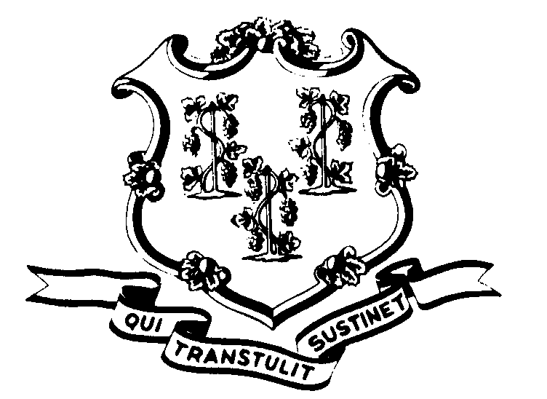

OFFICE OF POLICY AND MANAGEMENT

Office of Labor Relations

March 19, 2003

General Notice No. 2003-14

TO: Labor Relations Designees

SUBJECT: FOI Requests – SEBAC v. Rowland

A number of state agencies have received Freedom of Information requests on behalf of SEBAC and/or its constituent unions for a variety of information that ultimately relates to the above lawsuit. I am aware of requests from Dan Livingston on behalf of SEBAC, as well as requests from P-4, Engineering and Scientific and P-5, Administrative and Residual. The Governor’s office is coordinating these requests. This information has previously been shared with Agency heads regarding the SEBAC request. As always, agencies must continue to inform the Governor’s office of all FOI requests

Agency heads have been asked follow the normal procedure and acknowledge receipt of the request(s). Agencies are then to gather the information requested and provide copies of the same to Amy Lazzaro, Deputy Legal Counsel. The information will then be reviewed by outside legal counsel to ensure compliance with the FOI requests, as well as to ensure that they have all of the information provided to both SEBAC and the constituent unions due to the lawsuit.

Based upon the number of questions we have been receiving on this issue, I thought it might be helpful for you to have this information.

Questions from Agency Personnel Officers should be addressed to Amy Lazzaro at 524-7340.

Linda J. Yelmini

Linda J. Yelmini
Director of Labor Relations

