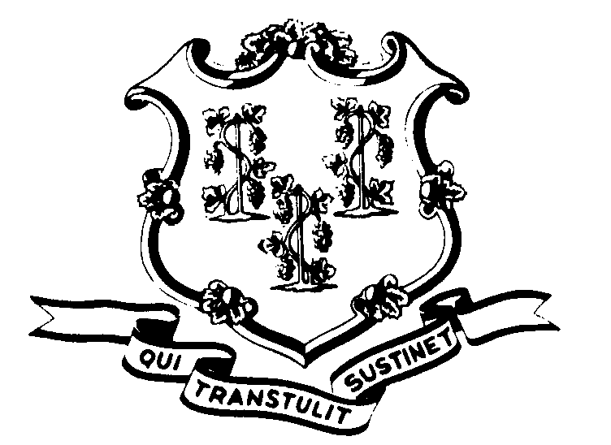STATE OF CONNECTICUT

OFFICE OF POLICY AND MANAGEMENT

Office of Labor Relations

February 25, 2003

General Notice 2003-07

TO: Labor Relations Designees

SUBJECT: February 18th Snow Storm

On Tuesday, February 18, 2003, Governor John G. Rowland indicated that nonessential state employees did not have to report to work until noon because of the adverse weather conditions.

Consistent with past practice, contractual and statutory provisions, you are reminded of the following:

- Nonessential employees scheduled to work on that day will record the time from the beginning of their scheduled workday until 12:00 noon as “WW”. Essential employees who did report to work will be paid in accordance with contractual and statutory provisions. Essential employees are not eligible for compensatory time off unless specifically provided in their collective bargaining agreement.
- Employees who were not scheduled to work on February 18th or who did not come in at noon (even though they were otherwise scheduled to work) are not covered by the Governor’s action. Employees absent because of illness or scheduled to take vacation leave, personal leave or other earned time shall have the appropriate leave balance charged and shall not be eligible for “WW” time. Employees on leave of absence without pay (including voluntary leave) or other scheduled day off, such as a pass day or “flex” day, shall not be eligible for “WW” time.
Labor Relations Designees with questions should be directed to the Office of Labor Relations at 418-6447. All others should contact their Central Personnel Office.

Linda J. Yelmini
Linda J. Yelmini
Director of Labor Relations

