STATE OF CONNECTICUT
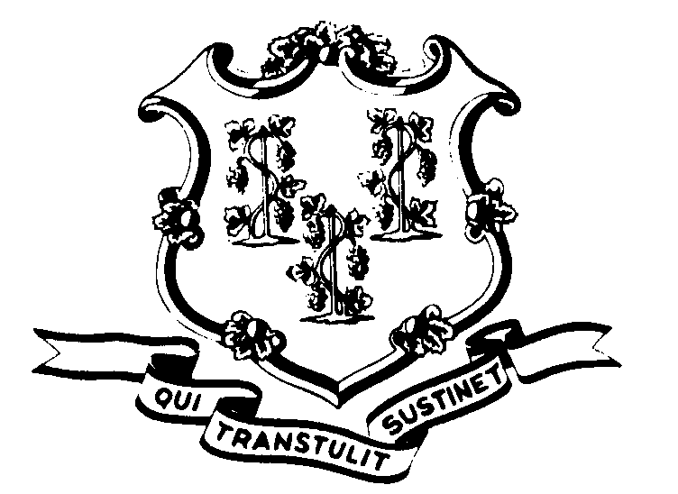

OFFICE OF POLICY AND MANAGEMENT

Office of Labor Relations

November 20, 2002

General Notice 2002-25

TO: Labor Relations Designees

SUBJECT: A&R Seniority Update

Agencies should have their P-5 seniority changes into APS by close of business Friday, November 22, 2002. There will be a new seniority list run made available on Monday, November 25, 2002.

Labor Relations Designees with questions regarding this should contact OLR at 418-6447. All others please direct your inquiries to your agency Personnel Office.

Linda J. Yelmini
Linda J. Yelmini
Director of Labor Relations

