STATE OF CONNECTICUT
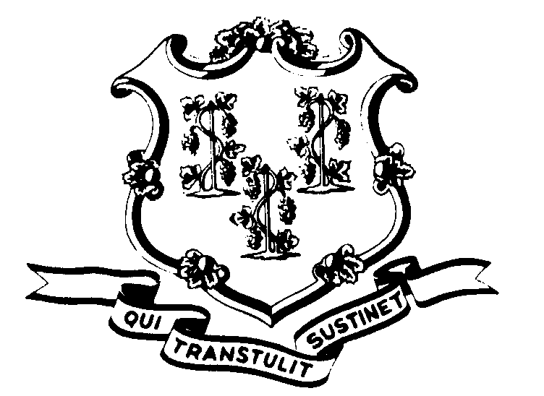

OFFICE OF POLICY AND MANAGEMENT

Office of Labor Relations

October 24, 2002

General Notice 2002-20

TO: Labor Relations Designees

SUBJECT: A&R Service Ratings – days & occasions

Effective with the rating period ending 9/30/02, “days and occasions” should not be noted on the service rating form except when the A&R member has used:
- more than 15 sick days in a year;
- less than 15 days, but have a “clear identifiable pattern of usage”, e.g., Mondays, Fridays, the day before or after holidays; OR
- less than 15 days but have repeated or extended occasions of unauthorized leave without pay.
If an A&R member notifies their personnel department by 11/24/02 that they want their sick leave usage removed from their service ratings for 2000 – 2002, you should comply if usage does not fall within one of the above exceptions. Removal can be accomplished, for those qualifying, by stapling a sheet to the service rating indicating the following:
“In compliance with a grievance settlement, all references to sick leave usage are hereby removed.”
Agency Labor Relations Designees with questions may contact Robert Curtis at 418-6241. All other questions should be directed to the agency personnel office.

Linda J. Yelmini

Linda J. Yelmini
Director of Labor Relations

