STATE OF CONNECTICUT
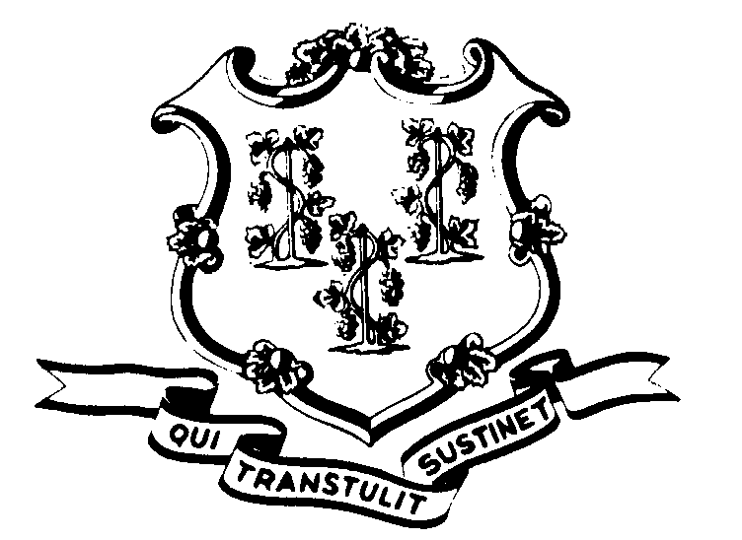

OFFICE OF POLICY AND MANAGEMENT

Office of Labor Relations

September 12, 2002

General Notice 2002-19

TO: Labor Relations Designees

SUBJECT: A&R Seniority List for layoff purposes

Attached is the A&R Seniority list by Classification as of June 30, 2002. It includes all of the corrections made to the system since the list was sent out in July as well as the A&R members in the Department of Education that were not included in that list. Thank you for all your work in updating this information.
Agency Labor Relations Designees with questions may contact the Office of Labor Relations at 418-6447. All other questions should be directed to the agency personnel office.

Linda J. Yelmini

Linda J. Yelmini
Director of Labor Relations

