STATE OF CONNECTICUT
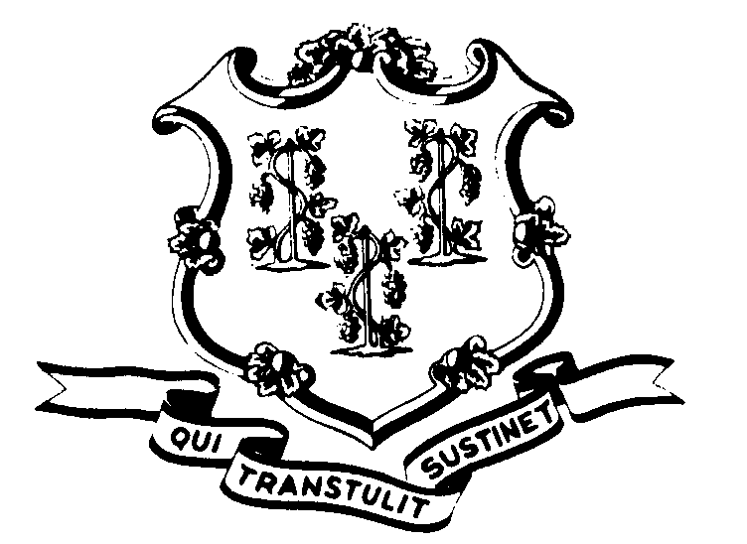

OFFICE OF POLICY AND MANAGEMENT

Office of Labor Relations

August 9, 2002

General Notice 2002-17

TO: Labor Relations Designees

SUBJECT: A&R AWS Programs

As you are aware, pursuant to the Interest Arbitration and a subsequent grievance arbitration described in OLR General Notice 2002-03, all agencies must have instituted an Alternative Work Schedule Program. Kindly forward to us a copy of your program as soon as possible, even if you have already done so. If you have no A&R members in your agency, please send us a fax or e-mail stating no A&R members. We want to make sure that our files are complete. Please either fax them to us at 418-6491 or e-mail them to me at Linda.Yelmini@po.state.ct.us. Thanks so much for your attention to this matter.
Agency Labor Relations Designees with questions may contact the Office of Labor Relations at 418-6447.

Linda J. Yelmini

Linda J. Yelmini
Director of Labor Relations

