STATE OF CONNECTICUT

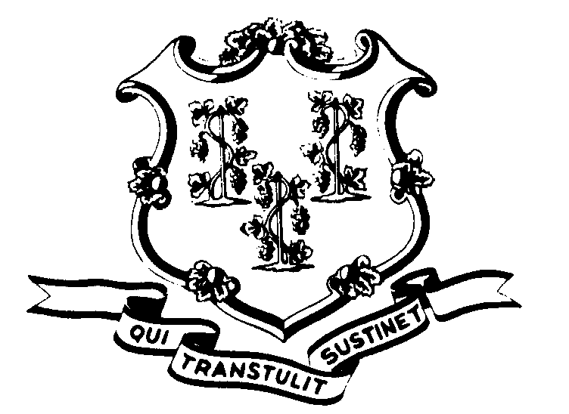

OFFICE OF POLICY AND MANAGEMENT

Office of Labor Relations

May 14, 2001

General Notice No. 2001-07

TO: Labor Relations Designees

SUBJECT: Union Organizing Drives

Due to union organizing activities in one of the State bargaining units, this policy has been revised and replaces OLR General Notice 84-4.

It is the policy of the State of Connecticut to treat all employee organizations on an impartial basis during union organizing drives. Agency decisions and practices should be consistent and should not favor either the current or the challenging union in their access to the bargaining unit employees. Agencies should also ensure that work operations are not impacted by the organizing and should protect the legal right of employees to refrain from union activity. All regular work rules would still apply during a union organizing campaign.

1. ORGANIZING ACTIVITIES BY EMPLOYEES: Employees of the facility may distribute written materials or engage in other organizing activities in non-work areas during non-work time (i.e. before and after work or during break and meal periods). Any employee(s) being solicited must also be on non-work time in non-work areas. Employees cannot report to work late or extend their break periods because they have been discussing the unions, handing out literature or signing intent cards. Employee stewards cannot use their ability to be released for contract and grievance administration to engage in organizing on State time.

2. ORGANIZING ACTIVITIES BY NON-EMPLOYEES: Solicitation and distribution of written materials by non-employees or off-duty employees is limited in terms of time and place. These organizing activities may be conducted: (1) in employee parking lots, (2) outside of State buildings, and (3) in the lobby and/or cafeteria of the building if these areas are open to the public, subject to the usual building security rules. There can be no disruption of work or cafeteria operations and the organizers may only solicit employees who are on non-work time (i.e. before or after work or during breaks.) No organizing activities will be allowed in work areas of the building. Off-duty employees are considered the same as non-employees in terms of their access to State property for purposes of organizing. Union representatives or officials

cannot use their right to employee access for purposes of contract and grievance administration to engage in organizing.

3. USE OF STATE EQUIPMENT: The use of any State equipment, including vehicles, copiers, telephones, fax machines, computers, e-mail, etc., for purposes of union organizing is strictly prohibited.

4. MEETINGS WITH EMPLOYEES: If an agency allows the current union to hold general employee meetings in State buildings before or after work or during the lunch period, the challenging union should be allowed, upon request, to schedule such a meeting. The agency can deny the request if it has not allowed union meetings in the past, if there is no suitable room available or if there would be any cost to the agency (e.g. paying overtime to someone responsible for locking the building).

5. BULLETIN BOARDS: If the agency provides bulletin board space to the current union, the existing procedures for the bulletin board would remain in effect but the challenging union should be allowed, upon request, the same posting ability. The agency should continue existing procedures to ensure that outdated materials are removed, that overcrowding and littering are avoided, and that the notices are not removed by supporters of the competing union. An agency-designated management official may remove notices which are defamatory, abusive or inflammatory and a copy of any removed notice should be sent to the Office of Labor Relations.

6. ENFORCEMENT: Employees who fail to comply with this policy should be advised of the restrictions and notified that further violations may result in discipline. Union organizers who are not employees and who fail to comply with these restrictions should be told of the policy and asked to leave the premises. Repeated violations, especially by non-employees, should be brought to the attention of the Office of Labor Relations. The enforcement of this policy should be handled by managers. Bargaining unit employees who notice a violation should bring it to the attention of the appropriate management official rather than to confront the violator.

This policy should be uniformly and consistently applied in order to ensure that work operations and State services are not affected, to protect the rights of the bargaining unit members and to avoid charges of favoritism. Since the State is legally required to remain neutral during any union organizing campaigns, State managers and supervisors cannot show preference to either employee organization.

Any questions about this policy from Agency Labor Relations Designees and any problems of repeated violations should be referred to the Office of Labor Relations.

Linda J. Yelmini
Linda J. Yelmini
Director of Labor Relations

