2019 JAG Local VCP Grant Program
Violent Crime Prevention (VCP)

(Distribution of JAG Local FY 2015 and FY 2016 Federal Grant Funds)

Project Narrative

Application Due to OPM: November 26, 2018

Instructions
- Before beginning to fill out your 2019 JAG Local VCP Grant Project Budget, please read and review the Grant Application Rules and Requirements document which outlines the intent of the grant program and addresses allowable and unallowable costs.
- The due date for the 2019 JAG Local VCP Grant application is November 26, 2018
- The project narrative document must be completed, signed and dated as indicated under Applicant Information.
- Once completed, please convert your completed project narrative document to PDF format.
- Please attach the completed project narrative PDF document, along with the other required grant application PDF documents as one "master" e-mail submittal and send the single e-mail to: Nichole.Howe@ct.gov

Applicant Information
Applicant Name:
Town:
Sign Here
SIGNATURE REQUIRED: 2019 JAG Local VCP Grant Manager
Date:

OPM CONTACTS
If you have any questions on the Project Narrative, please contact:
Stephen Moniz: Stephen.Moniz@ct.gov
If you have questions concerning the submission process or accessing the grants portal:

Nichole Howe: Nichole.Howe@ct.gov
John Forbes: John.Forbes@ct.gov

Please provide the following information on your police departments use of Police Body Worn Cameras
Question | Response
Please indicate the number of existing body-worn cameras that are in use at your police department.
Please indicate the number of officers currently using body-worn cameras.

Programs
(Questions 1-5)

- Indicate the types of programs you plan to implement. (Check all that apply)
☐ | Community Policing Strategies
☐ | Response to Gun Crime and Shootings
☐ | Response to Gang/Group(s) Crime
☐ | Response to Domestic Violence
☐ | Response to Sexual Assault
☐ | Response to Mentally Ill Offenders

- Please briefly explain how the activities will address violent crime? Describe purpose of activities and expected outcome.

- Do you plan to hold an event using the JAG funds?
(Examples Include: Safe streets operations, community outreach campaigns)

☐ Yes | ☐ No (Skip to next section)

- What types of events do you plan for the grant period?

Check All that Apply | Event | Topic
☐ | Community Outreach
☐ | Educational Events
☐ | Media Campaign
☐ | Community Meetings
☐ | Citizen Police Academy
☐ | Other

- Please provide a brief explanation of the anticipated events?

Personnel
Questions (6-8)

- Do you plan to use JAG funds to support overtime hours?

☐ Yes | ☐ No (Skip to next section)

- Indicate the type of position supported with overtime hours using JAG funds. Briefly State the purpose of the overtime.
(Examples Include: Attend training, surveillance operation, special patrol, citizen academy)

Check All That Apply | Position Title | Purpose of Overtime
☐ | Police officer
☐ | Corporal
☐ | Detective or Investigator
☐ | Sergeant
☐ | Lieutenant
☐ | Captain
☐ | Major
☐ | Lieutenant Colonel
☐ | Colonel

- Please provide an estimate of the Over-Time hours to be supported by JAG Funds.

Equipment Purchases and Technology Investments
Questions (9-11)

- Do you plan to use JAG funds for equipment purchases and/or technology investments?

☐ Yes | ☐ No (Skip to next section)

- What types of equipment purchases and/or technology investments
(Please see the detailed JAG Eligible Equipment List in Appendix A for more information)

Check All That Apply | Equipment Category
☐ | Camera/Surveillance Equipment
☐ | Computer Equipment
☐ | Vehicles and Accessories
☐ | Duty Equipment (not including weapons)
☐ | Technology
☐ | Forensics/Evidence
☐ | Canines and Equipment
☐ | Medical/Overdose Response

- Describe any efficiencies or cost savings to be achieved as a result of any equipment purchases and or technology investments.

Training
(Questions 12 -13)

- Do you plan to conduct any training during the grant period?

☐ Yes | ☐ No (Skip to next section)

- Please indicate the training topics, target audience, and provide an estimate of the number of persons to be trained. Please also identify the type of trainer. (Examples Include: Police Officer, POST, FBI, IAPC, or FLETC)

Task Forces
(Questions 14-15)

- Do you plan to use JAG funds to support a multijurisdictional task force activity?
☐ Yes |  |  |  | ☐ No (Skip to next section)
14a) Indicate the types of task forces below.
Task Force | Yes | No | Is this a Multijurisdictional  Task Force? |  | Estimated number of Hours during grant period
Anti-Gang Task Force | ☐ | ☐ | ☐
Anti-Gun Task Force | ☐ | ☐ | ☐
Drug Task Force | ☐ | ☐ | ☐
Violent Crime Task Force | ☐ | ☐ | ☐
Other | ☐ | ☐ | ☐
If other, please explain:

15) Please provide a brief summary of the task force activities that will be supported by the JAG funds.

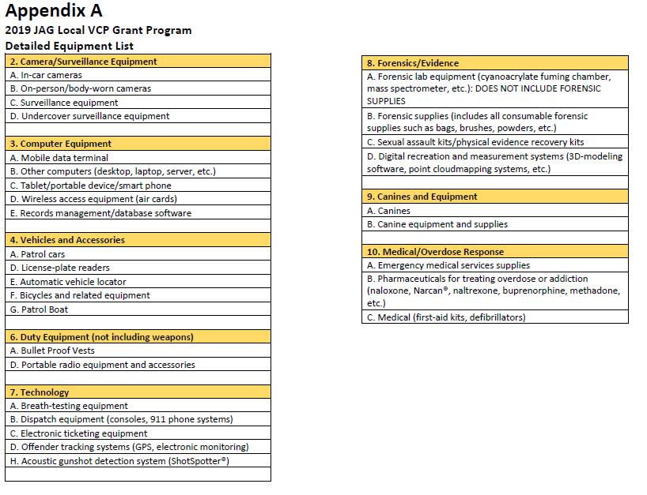Page 8 | 8

