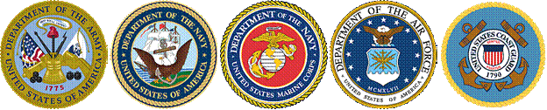
SOLDIERS, SAILORS AND MARINES FUND

http://www.ct.gov/ssmf
AGENCY PURPOSE

- To provide temporary financial assistance to needy wartime veterans and their families.
- To provide veterans with guidance and information focused on assisting them in regaining financial self-sufficiency.
- To refer veterans to appropriate state, federal and local organizations in circumstances where long-term assistance is required.

Pursuant to Public Act 13-247 and the budget enacted for Fiscal Year 2015, the operations of this agency will be transferred to the American Legion effective July 1, 2014. A grant to the American Legion for administrative expenses is proposed under the Department of Veterans’ Affairs.

