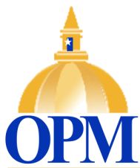
Office of Policy and Management

http://www.ct.gov/opm
AGENCY PURPOSE

- To support the Governor in the development, implementation and analysis of various policies relating to assets management, criminal justice, health and human services, and information technology systems.
- To prepare the executive budget and to execute biennial budgets as enacted into law.
- To provide analyses, evaluations and recommendations to the Governor regarding the financial implications of state policies and practices.
- To formulate policy pertaining to the relationship between the state and Connecticut’s municipalities.
- To improve the effectiveness of state services by ensuring the efficient use of resources through research, policy development and interagency coordination.
- To deliver timely and effective labor relations and collective bargaining services on behalf of the state as an employer.
- To review and monitor the core financial management policies and practices in state agencies.
- To ensure the implementation of programs enacted by law.

