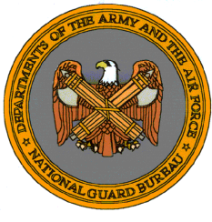
Military Department

http:/www.ct.gov/mil
Agency Purpose
- To provide trained and disciplined forces for domestic emergencies or as otherwise required by law.
- To maintain properly trained and equipped units available for prompt mobilization for war or national emergencies.
- To augment federal, state, and local emergency responders in the event of large-scale emergencies and disasters, by providing trained military personnel, military facilities, equipment and supplies.
Connecticut Military Facilities
