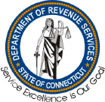 Department of Revenue Services

<http://www.ct.gov/drs>

Agency Purpose

* To administer the tax laws of the State of Connecticut.
* To collect the tax revenues in the most cost effective manner.
* To strive to achieve the highest level of voluntary compliance through accurate, efficient and courteous customer services.
* To perform in a manner which instills public confidence in the integrity and fairness of the department’s programs.