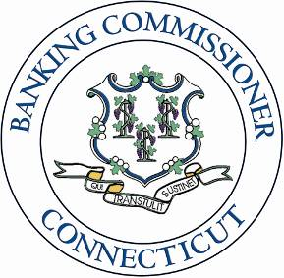
Department of Banking

http://www.ct.gov/dob

Agency PurposE
- To administer the state's banking and related laws.
- To ensure the safety and soundness of regulated depository institutions.
- To protect Connecticut consumers and investors through various activities including administration of the Truth-in-Lending Act and other consumer credit laws.

