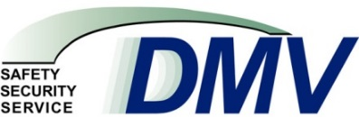
DEPARTMENT OF MOTOR VEHICLES

http://www.ct.gov/dmv
Agency Purpose
- To issue identity-related credentials according to stringent guidelines for individuals, motor vehicle operators and their vehicles, and for companies involved in vehicle-related businesses.
- To promote and advance public safety, security and service through the regulation of drivers, their motor vehicles and certain vehicle-related businesses.
- To maintain records on operators, vehicles, and revenues and to make such records available to authorized persons and agencies.
- To enforce the statutes regarding motor vehicles and their operation and to impose sanctions on the credential-holders who violate laws and regulations.
- To collect revenue for various state funds, most of which is appropriated within the Special Transportation Fund for the construction and maintenance of the state’s highways.
- To employ new and innovative measures and strategies to deliver high quality, innovative services to customers.

