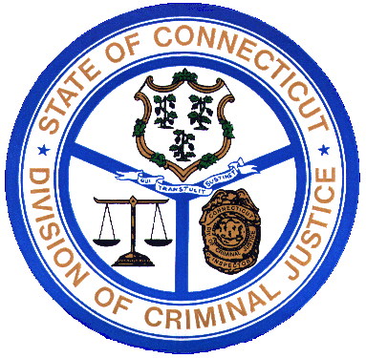
Division of Criminal Justice

http://www.ct.gov/csao
Agency Purpose

- To investigate and prosecute all criminal matters fairly, consistently, and with the highest regard for public safety and the rights of all persons.
- To uphold the law and protect the public, respect the rights of victims, witnesses and defendants, and maintain the highest ethical standards as ministers of justice.
- To provide training and leadership to Connecticut’s prosecutors and the law enforcement community.
- To promote and strengthen innovative strategies in the administration of state criminal justice systems.
- To strengthen partnerships for safer communities and enhance the state’s capacity to prevent, solve, and control crime.
- To take advantage of state and federal laws to seize money, property, or other assets used in the furtherance of illegal drug trafficking and other crimes.
- To collect bonds forfeited in criminal cases when a defendant out on bond does not appear in court.
- To protect witnesses and victims from harm.
- To uphold the rights and improve services to Connecticut’s crime victims.
- To prosecute violations of court orders.
- To ensure access to all appropriate diversionary programs.

