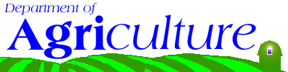
Department of Agriculture

http://www.ct.gov/doag
Agency Purpose
- To foster agriculture by developing, promoting and regulating agriculture businesses and protecting agricultural and aquacultural resources.
- To protect consumers and animal health by regulating, inspecting and enforcing animal care and animal health standards for pet shops and commercial kennels.
- To protect public health and animal agriculture by enforcing livestock and poultry disease statutes and administering prevention and control programs for animal diseases.
- To protect domestic animals by responding to and investigating complaints about animal cruelty and neglect.
- To protect public safety by supporting local animal control and police enforcement of animal-bite statutes.
- To protect public health by regulating, inspecting and enforcing food production and manufacturing standards for the shellfish, fluid milk and cheese manufacturing industries.
- To preserve agricultural resources by restricting non-agricultural uses, thus preserving the land for food and fiber production.

