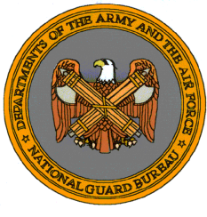
Military Department
http://www.mil.state.ct.us/
Agency Purpose
- The Military Department is composed of the Connecticut Army National Guard, Air National Guard and the State Militia.
- The state mission is to provide trained and disciplined forces for domestic emergencies or as otherwise required by law.
- The federal mission is to maintain properly trained and equipped units available for prompt mobilization for war or national emergencies.
- Collectively, the Connecticut Army and Air National Guard and the organized militia augment federal, state, and local emergency responders in the event of large-scale emergencies and disasters, providing trained military personnel, military facilities, equipment and supplies.
Connecticut Military Facilities
