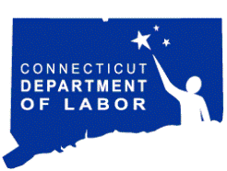Department of Labor

http://www.ctdol.state.ct.us/

Agency Purpose

The mission of the Connecticut Department of Labor (CTDOL) is to protect and promote the interests of Connecticut’s workers and assist workers and employers to be competitive in the global economy.

CTDOL accomplishes its mission by providing a variety of services that benefit the workplace. Services include: income support that assists workers between jobs and stimulates the local economy; protection on the job (through regulation of wages, safety and working conditions, and on-site health and safety consultations); work-related training programs; job search and recruitment assistance (through the local and regional job fairs and employer recruitments at *CTWorks* offices); tax credit incentive programs and maintenance of the collective bargaining relationship. As the Connecticut arm of the U.S. Bureau of Labor Statistics, the department collects, analyzes and disseminates workforce data to inform businesses, the general public, educational institutions, and government policymakers about employment issues and trends.The services provided by CTDOL and the resulting successes of individuals using those services are heavily impacted by Connecticut’s unemployment rate.

The chart below reflects the non-farm unemployment rates for Connecticut and the U.S. for January 2012 through December 2012.

|  |
| --- |
|  |