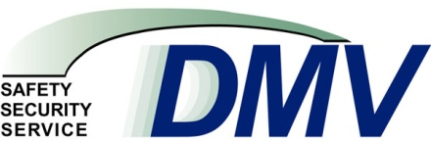 Department of Motor Vehicles
Agency Purpose
- Issue identity-related credentials according to stringent guidelines to assure integrity of such individuals, motor vehicle operators and their vehicles, and for companies involved in vehicle-related businesses.
- Promote and advance public safety, security and service through the regulation of drivers, their motor vehicles and certain vehicle-related businesses.
- Maintain records on operators, vehicles, and revenues and making such available to authorized persons and agencies.
- Enforce the statutes regarding motor vehicles and their operation and impose sanctions on the credential-holders who violate laws and regulations.
- Collect revenue for various state agencies, most of which is appropriated within the Special Transportation Fund, for the construction and maintenance of the state’s highways.
- Employ new and innovative measures and strategies to deliver high quality, innovative services to customers.

