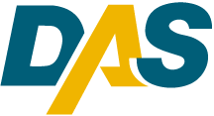Department of Administrative Services

http://www.das.state.ct.us/
Agency Purpose

The Department of Administrative Services (DAS) is the single agency in charge of providing administrative services to other state agencies.
DAS’s mission is to provide statewide policy to State of Connecticut agencies on matters related to purchasing, motor vehicle fleet, human resources, information technology, property and facilities management, along with other centralized services, and to supply the best possible people, goods and services to the agencies on time, in accordance with their business needs, and within statutory requirements.
DAS’s services enable the state to save money by taking advantage of economies of scale and streamlining services and processes. The services provided cross state agencies, municipalities, vendors, colleges and universities, non-profit organizations and the public at large.

