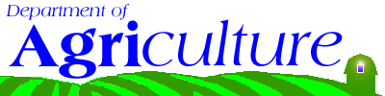
Department of Agriculture

http://www.ct.gov/doag
Agency Purpose
- Foster agriculture by developing, promoting and regulating agriculture businesses and protecting agricultural and aquacultural resources.
- Protect consumers and animal health by regulating, inspecting and enforcing animal care and animal health standards for pet shops and commercial kennels.
- Protect public health and animal agriculture by enforcing livestock and poultry disease statutes and administering animal disease prevention and control programs.
- Protect domestic animals by responding to and investigating animal cruelty and animal neglect complaints.
- Protect public safety by supporting local animal control and police enforcement of animal bite statutes.
- Protect public health by regulating, inspecting and enforcing food production and manufacturing standards for the shellfish, fluid milk, cheese manufacturing industries and small non-USDA inspected poultry slaughter operations.
- Preserve agricultural and aquacultural resources by restricting non-agricultural uses and prohibiting their partitioning thus preserving the land and underwater land for food and fiber production.

