Town of Manchester, Connecticut:
RFQ, Appendum B, filed October 30, 2014.
REQUEST FOR QUALIFICATIONS (RFQ)
Connecticut Municipalities Broadband Infrastructure Upgrade and Expansion Project – filed September 15, 2014.
Manchester, a township and city in Hartford County, Connecticut, United States, has chosen to join the RFQ to gather ideas and recommendations for developing, upgrading, and expanding broadband infrastructure and improving access to high-speed Internet across. As of the 2010 census, the town had a total population of 58,241. For information on the RFQ addenda filed by Connecticut municipalities, refer to RFQ, C. Public Assets and Infrastructure, 1. Extensive RE Assets Exist, at page 11 of the RFQ.
Manchester has chosen to structure its RFQ Addendum based on responses provided to a question posed by Jack McCoy, the president of the state association of chief information officers, GMIS October 24, 2014 Meeting, entitled “Gig RFQ and Inside the Muni Connectivity.”
“What would prospective providers want to hear from Municipalities in Appendix B that would encourage them to respond to the Request For Qualifications?”
1. Identify Customers for Gig Internet/Ethernet use.
2. Locate the Gig Broadband customers for path engineering.
3. Show how your municipality is minimizing or expediting the fiber build application process.
4. Identify Municipality / Respondents partnerships that could reduce Capital Expenditures (CapX) for a Respondents to the RFQ.
5. Identify provider revenue from Gig Broadband.

Manchester Response to Question 1: Identify Customers for Gig Internet/Ethernet use.
As detailed in Response no. 4 below, Manchester has actively been developing a citywide Municipal Gain Fiber Optic Network since the 1990s, utilizing the statutory “municipal gain” which provides the town with rent-free access to all poles and conduit located in the town. In addition having linked all town building and other community anchor institutions, Manchester intends to put this Network to use for economic development purposes. For example, The Broad Street area in town designated for re-development will attract new tenants and broadband customers of all kinds, who can benefit from ultra-high speed Internet connections. Connecticut generally and Manchester specifically, is home to technology-oriented firms with “Big Data” interests, including the use of medical records or imaging data or data intensive technology engineering processes. Additionally, Manchester’s medical office community is largely located coincident to the Manchester Municipal Gain FiberNet. Both represent potential Gig Broadband customer clusters that in turn can spawn further development deeper into the town (see map below).
Manchester Response to Question 2: Locate the Gig Broadband customers for path engineering.
Manchester has designated Broad Street Re-development space from the East Parkade-to-Center Springs Park linking the Downtown District core on the South and our hospital, ECHN, to the North as a target path destination for Gig Broadband (see map). Prospective customers will be in a newly constructed town center location that is currently served by the Manchester Municipal Gain FiberNet. As noted above, the towns fiber network is attached to the statutory municipal gain and thus enjoys rent-free pole and conduit access. Connecticut not only has the municipal gain access, but enjoys state-level regulatory authority over all utility operations in the public rights of way, including rapid make-ready procedures and schedules, and uniform interconnection agreements and pricing. Connecticut also has instituted a “single pole administrator” process with a central database, transparent to all attachers, which further streamlines the attachment process, with rates subject to rate-of-return regulatory examinations by the state regulatory agency.
Manchester Response to Question 3: Show how your municipality is minimizing or expediting the fiber build Gig Broadband application process.
Manchester Permitting Process- Manchester has an Economic Development Staff organized to support the Broad Street Development Project including funding for development support. As noted in Question no. 2, Connecticut has a statewide centralized regulatory process for all utility work in the public rights of way, including a municipal gain provision providing each municipality with access to all poles and conduit, rent free. Manchester is a member of the state association of chief information officers, CT-GMIS. Manchester is also a founding member of the state working group overseeing the utility use of the public rights of way under the authority of the state regulatory body, PURA, with Manchester playing a key role in the PURA PROW Working Group Engineering Subcommittee. Manchester was involved in developing the Single Pole Administrator process recently approved by PURA and has experience with the new centralized database of pole attachment and scheduling information, the NOTIFY automated application process. CT-GMIS members, in coordinated work with CCM, CRCOG and the pole owners, drafted the new template Municipal Pole Attachment Agreement for all municipal attachments in the state, featuring a mandatory 45 day application response provision to be enforced by the state regulator.
Manchester Response to Question 4: Identify Municipality / Respondents partnerships that could reduce Capital Expenditures (CapX) for Respondents to the RFQ.
Manchester has developed a citywide Municipal Gain Fiber Optic Network that it will share with Respondents. The provider could use municipal building FiberNet switch rack space for nodes or Municipal Gain fiber bandwidth to “bootstrap” a rapid initial CapX build to the targeted customers. Additionally, Manchester would support a request for sharing bandwidth on the State’s Nutmeg Network and Internet Access through the University of Connecticut 100Gigbps internet Service Provider .
Manchester Response to Question 5: Identify provider revenue from Gig Broadband.
Manchester has its own municipal needs for connectivity that will generate Internet service revenues to help fund Respondent investments made in building a Gig Internet/Ethernet connectivity resource in the municipality. Manchester will also certainly help Respondents to reach out to community anchor institutions throughout the town to seek revenues from those customers.
While Manchester has already built a citywide Municipal Gain Fiber Optic Network, new links and maintenance represent new business opportunities for Gig RFQ Qualified Vendor(s).

From Question 1 above - below - Manchester’s FiberNet map with Doctors and Broad Street Redevelopment locations pinned and highlighted as examples of Gig Internet/Ethernet Broadband potential commercial connections.
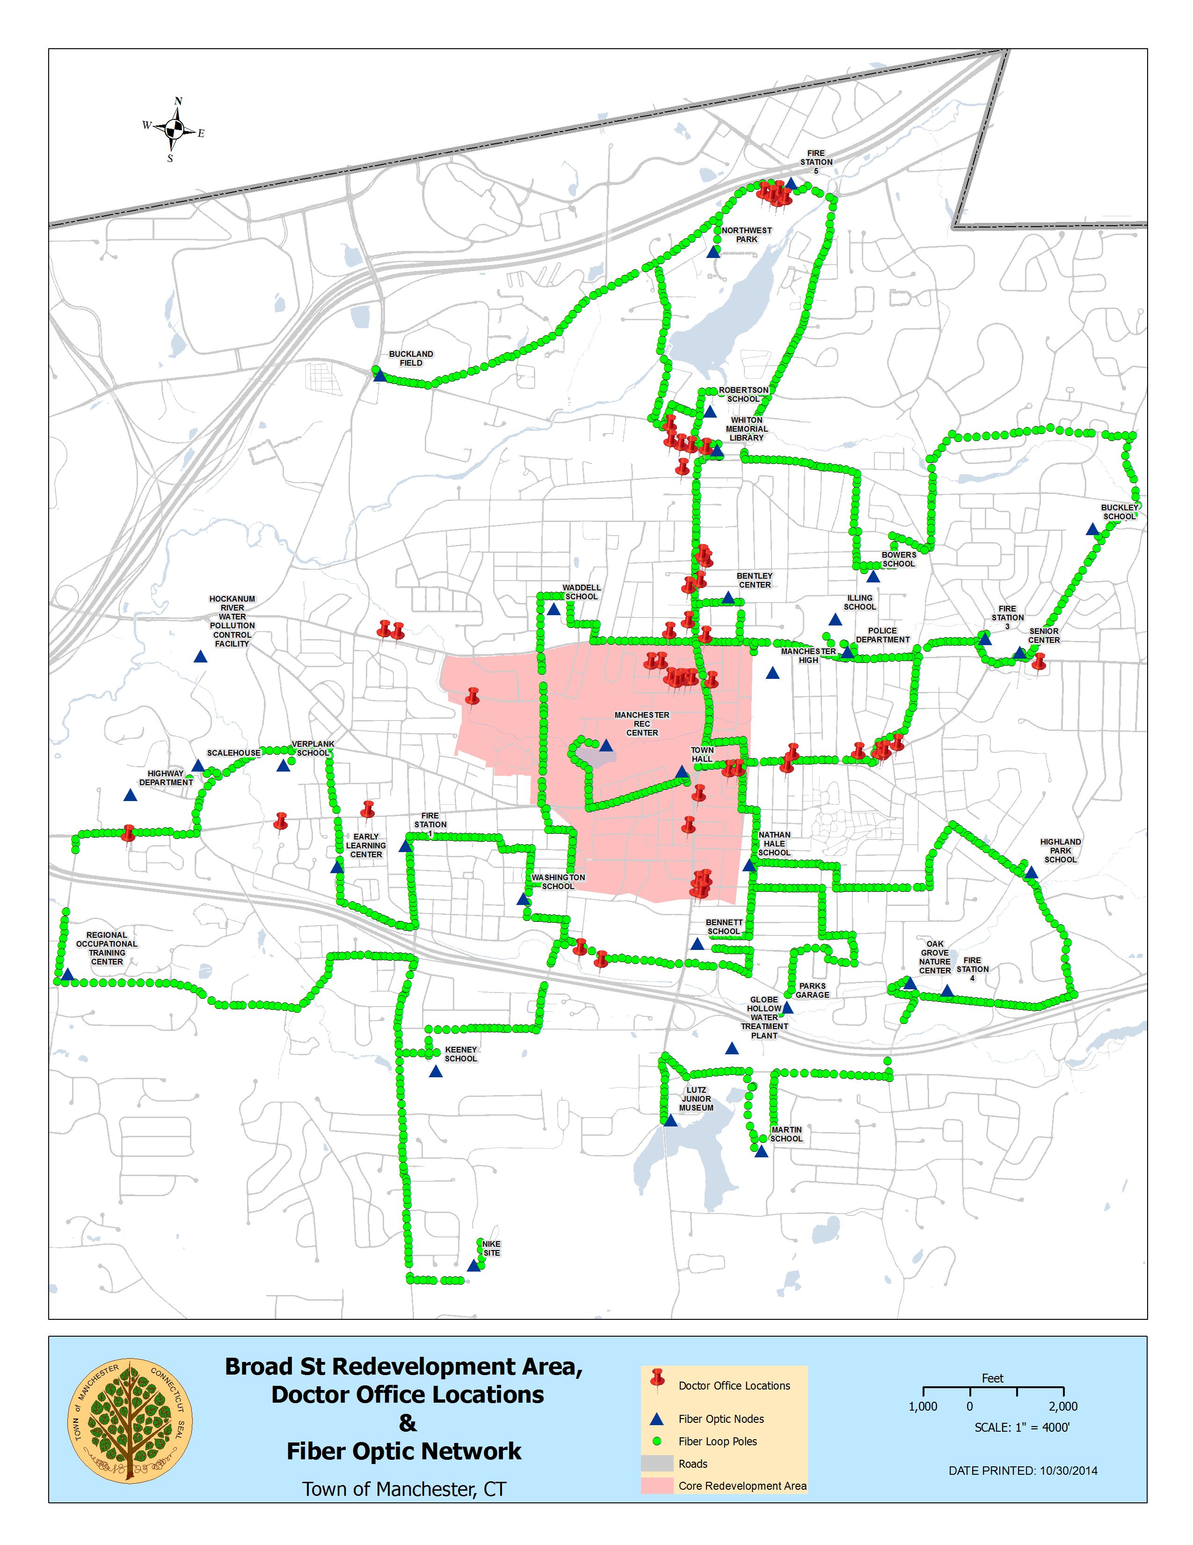

Market assessment
for the medical/education anchor and
business enterprise environment
Manchester’s new emphasis on its large medical enterprise cluster, highlighted in the map above, and its long standing industrial base with companies such as Timkin, GE, and others located in industrial park spaces on Progress Drive, Chapel and Main Streets, all couple with the economic attraction of the largest retail concentration between Boston and New York City - the Buckland to Evergreen Walk retail cluster, to make this very successful business concentration a prime innovation center.
Vision Medical/Education Anchor
An economic driver and anchor for the town, the Medical and Educational District would bring additional employment, users and activity to Broad Street and the Town of Manchester.
Rationale
Medical and educational developments are high economic impact uses, drawing employees, students, visitors, and others on a daily basis. Medical and educational institutions also attract investment, innovation and spin-off projects in a neighborhood, town or city. If implemented strategically and smoothly, they can also become catalytic, generating demand for additional development projects. These resilient, economically stable anchor uses receive significant public and private investment and endowment, and are expected to remain leading industries well into the future. LWLP has spoken to several healthcare and educational institutions over the past four months, and believes that there is reasonably strong interest in exploring the development of medical and/or educational facilities on and around the Parkade Site.
Differentiator
Unlike standalone medical or educational facilities and buildings, this medical and educational mixed-use development would become an integrated district that is well connected with the surrounding uses along Broad Street, ECHN, Center Springs Park and Downtown Main Street. It must tie into Center Springs Park and the existing ECHN medical area to form a place with maximum potential and benefits for Manchester.
Benefits
The medical and educational district would bring new economic development and jobs to Manchester, catalyzing rather than competing with existing development in the town. The district would encourage spin-off development, such as specialty housing and retail, additional office and laboratory space, and other projects that are leveraging medical and/or educational institutions. Medical and educational anchor institutions usually work with and are integrated into communities to create shared value in terms of added social, economic and community benefits. Medical and educational industries are also considered to be highly resilient, as they have remained strong economic generators and job providers throughout recessions, wars, and other unforeseen changes to the social or economic well-being of the country. The healthcare and educational sectors have historically adapted to economic restructuring and the ongoing changing needs of the workforce, and would likely continue to do so. Many towns and cities that have otherwise struggled, remain on relatively steady economic footing because of the presence of an anchor educational and/or medical institution.
Manchester’s innovation demand depends on an ever-increasing communications resources – the State’s Gig Internet RFQ opens options on a Digital Super Highway for the city.
Downtown Main Street Special Services District:
Manchester’s Downtown Special Services District has a property tax exemption for technology. The availability of current High Speed Internet, combined with the tax incentive, coupled with new Gig Internet would introduce a new combination of economic factors for the downtown. Already home to Fuss and O’Neal’s retail data center and Axis901 which houses a number of startup software development teams, Gig Internet will incent additional enterprise in this growing and changing area. Gig Internet is an addition to this street’s active Innovation Economy at work in Manchester.

