Recognizing Heat Stress
As summer approaches it is important to remember that taking part in physical activities on warm or hot days can be dangerous. You may be subject to heat stress which includes heat cramps, heat exhaustion or even heat stroke. We all vary in our susceptibility to these heat related conditions, but everyone can suffer from heat stress under the right conditions. Some contributing factors may include: lack of physical fitness, age, obesity, infection, dehydration, sunburn or chronic disease.

What is Heat Stress?
Heat Stress is the adverse effects that happen to your body when it is overheated, as shown in “The Heat Equation” below.. The adverse effects usually happen in the following order but a person can proceed rapidly through these conditions.
- Dehydration
- Heat Cramps
  - Caused by heavy sweating with inadequate electrolyte replacement
  - Signs involve muscular pains due largely to loss of salt
- Heat exhaustion
  - Occurs from increased stress on various body organs including inadequate blood circulation due to dehydration
  - Possible symptoms include: pale/clammy skin, tiredness, weakness, headache, nausea, dizziness, possible fainting
- Heat stroke
  - The most serious form of heat stress
  - Temperature regulation fails and the body temperature rises to critical levels and the sweating mechanism of the body is disturbed
  - Heat stroke is an immediate, life-threatening emergency and medical care is urgently needed
  - Some symptoms include: skin is hot, lack of perspiration, nausea, dizziness, confusion, pulse rapid and strong, person may be unconscious

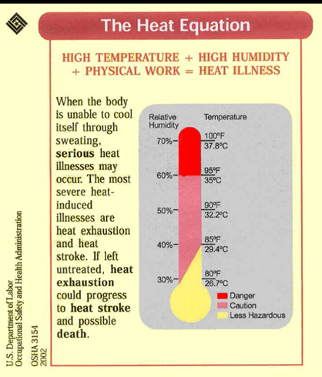
Controlling Heat Stress
Heat Stress can affect health and safety. There are steps we can take to help protect ourselves and others from heat stress and related illnesses.
- Drink at least one cup of water every 20 minutes
- Limit activity to the coolest part of the day
- Recognize the signs of heat-related disorders
- Wear lightweight/light-colored clothing
- Avoid caffeinated beverages
- Take rest breaks
- If you start to experience cramps, stop what you are doing to cool off and rest
- Seek help if you think you, or someone else, may be experiencing heat stress

Heat and Pets
- Never leave your pet in a parked car – they can suffer from heat-related illness too
- Even in cool temperaturs, cars can heat up to dangerous temperatures very quickly
  - Leaving a window open is not enough – tempertures inside the car can rise almost 20 degress Fahrenheit within the first 10 minutes, even with a window cracked open
- Provide plenty of fresh water for your pets, and leave the water in a shady area

Additional Information
- FEMA – Extreme Heat: http://www.ready.gov/heat
- Connecticut Department of Public Health, Heat Safety Precautions – https://portal.ct.gov/DPH/Communications/Crisis-and-Emergency-Risk-Communication/Extreme-Heat
Please visit OCC’s website.

U.S. Department of Labor, Occupational Safety and Health Administration, OSHA 3154, 2002

