
Updated on
August 4, 2020

OCC FACT SHEET: ELECTRIC SUPPLIER MARKET, JUNE 2019 THROUGH MAY 2020

The following is an update to the Office of Consumer Counsel’s (OCC’s) Electric Supplier Market Fact Sheet, originally created in 2014. The numbers provided herein are based on data submitted as compliance filings in the Public Utilities Regulatory Authority’s Docket Number 06-10-22.

- Retail suppliers serve 20.8% of Eversource Energy (Eversource) residential customers and 25.7% of United Illuminating (UI) residential customers, in May 2020.

- In the month of May 2020, over five out of ten residential supplier customers paid more than the Standard Offer in Eversource territory, and nearly five out of ten residential supplier customers paid more than the Standard Offer in UI territory.

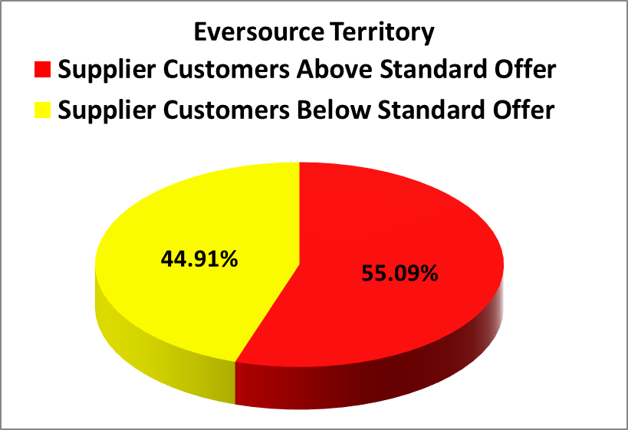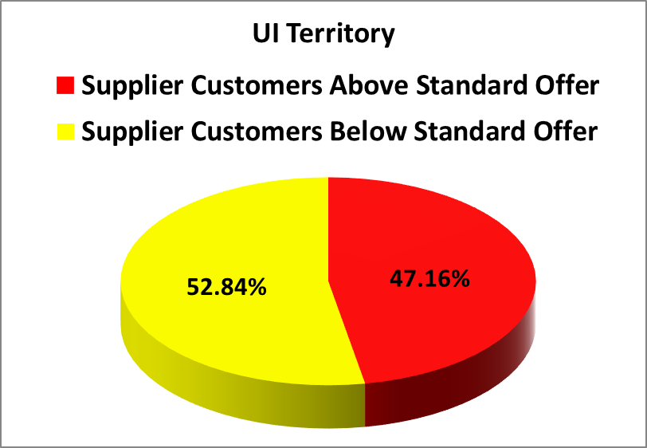
- In the month May 2020, residential Eversource customers who chose suppliers paid in aggregate $1,199,436 more than the Standard Offer for their electric generation, and residential UI customers who chose suppliers paid in aggregate $44,472 more than the Standard Offer.
- For the rolling year of June 2019 through May 2020, residential consumers who chose a retail supplier paid, in aggregate, $41,965,903 more than the Standard Offer.
- The Standard Offer for Eversource customers from January 1, 2019 through June 30, 2019 was 10.143 cents/kWh. From July 1, 2019 through December 31, 2019, the Standard Offer for Eversource customers was 8.123 cents/kWh. The Standard Offer for Eversource customers from January 1, 2020 through June 30, 2020 is 9.414 cents/kWh.
- From January 1, 2019 through June 30, 2019, the Standard Offer for UI customers was 11.2263 cents/kWh. From July 1, 2019 through December 31, 2019, the Standard Offer for UI customers was 8.3532 cents/kWh. From January 1, 2020 through June 30, 2020, the Standard Offer for UI customers is 10.5607 cents/kWh.

Please feel free to contact the Office of Consumer Counsel at 860-827-2900 or occ.info@ct.gov if you have any questions about this information.

This Fact Sheet only examines available data regarding pricing by electric suppliers. While some suppliers may offer products or services to customers such as airline miles or a product with additional renewable energy content, there is no data available to quantify the value of such offers. OCC recommends that customers look carefully at the fine print for offers for additional products or services that come with higher prices, to ensure they are getting sufficient value to justify the higher price tag.
These calculations are based on an assumption of 750/month kWh usage.

