Updated on
January 16, 2019

OCC FACT SHEET: ELECTRIC SUPPLIER MARKET, JANUARY 2019 THROUGH DECEMBER 2019

The following is an update to the Office of Consumer Counsel’s (OCC’s) Electric Supplier Market Fact Sheet, originally created in 2014. The numbers provided herein are based on data submitted as compliance filings in the Public Utilities Regulatory Authority’s Docket Number 06-10-22.

- Retail suppliers serve 22.6% of Eversource Energy (Eversource) residential customers and 28.3% of United Illuminating (UI) residential customers, in December 2019.

- In the month of December 2019, eight out of ten residential supplier customers paid more than the Standard Offer in Eversource territory, and over eight out of ten residential supplier customers paid more than the Standard Offer in UI territory.

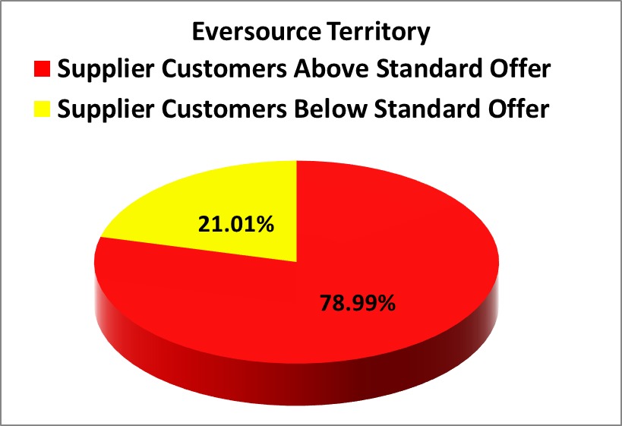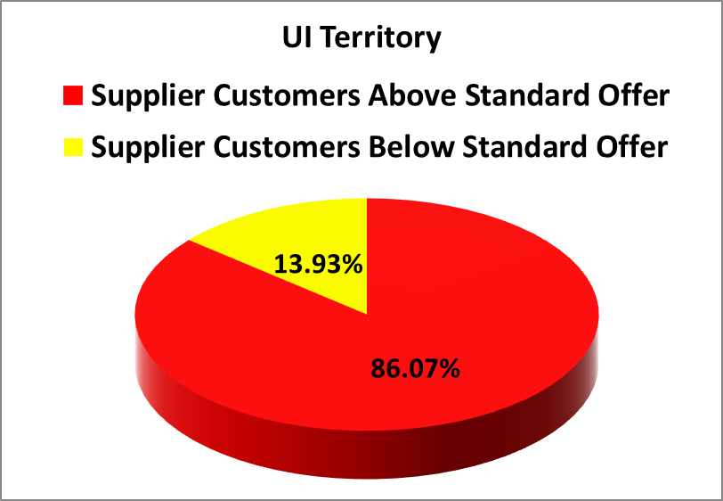
- In the month December 2019, residential Eversource customers who chose suppliers paid in aggregate $3,784,738 more than the Standard Offer for their electric generation, and residential UI customers who chose suppliers paid in aggregate $1,591,656 more than the Standard Offer.
- For the rolling year of January 2019 through December 2019, residential consumers who chose a retail supplier paid, in aggregate, $38,613,050 more than the Standard Offer.
- The Standard Offer for Eversource customers from January 1, 2019 through June 30, 2019 was 10.143 cents/kWh. From July 1, 2019 through December 31, 2019, the Standard Offer for Eversource customers was 8.123 cents/kWh.
- From January 1, 2019 through June 30, 2019, the Standard Offer for UI customers was 11.2263 cents/kWh. From July 1, 2019 through December 31, 2019, the Standard Offer for UI customers was 8.3532 cents/kWh.
- The following table lists all electric suppliers who charged at least 20% of their residential customers 12.184 cents/kWh (50% higher than Eversource standard service) or 12.529 cents/kWh (50% higher than UI standard service) or more in the month of December. The phone numbers for each supplier are taken from those listed at energizect.com or the website for that supplier.

Suppliers Charging at Least 20% of their Customers 50% or more than Standard Offer in December
Electric Suppliers | % of Eversource Customers paying over 12.184 cents | % of UI Customers paying over 12.529 cents | Supplier Phone Number
Choice Energy | 91.01% | 60.88% | (888) 565-4490
Energy Plus Holdings, LLC | 89.48% | 93.12% | (888) 766-3509
North American Power and Gas LLC | 43.94% | 37.98% | (877) 572-0442
Ambit Energy LLC | 24.99% | 33.41% | (877) 282-6248
Mega Energy of New England LLC | 45.53% | 28.08% | (866) 769-3799
Discount Power, Inc. | N/A | 20.37%
NRG Retail Solutions | 84.62% | 86.02% | (855) 500-8703
Public Power LLC | 25.66% | 32.28% | (888) 354-4415
Spark Energy LP | 81.18% | 58.44% | (877) 547-7275
Sunwave Gas and Power CT Inc. | 29.81% | N/A | (855) 478-6928
Verde Energy USA Inc | 59.53% | 40.52% | (800) 388-3862
Viridian Energy Inc | 71.81% | 69.98% | (866) 663-2508
Aequitas Energy Inc | N/A | 75.00% | (855) 799-8200

Please feel free to contact the Office of Consumer Counsel at 860-827-2900 or occ.info@ct.gov if you have any questions about this information.

This Fact Sheet only examines available data regarding pricing by electric suppliers. While some suppliers may offer products or services to customers such as airline miles or a product with additional renewable energy content, there is no data available to quantify the value of such offers. OCC recommends that customers look carefully at the fine print for offers for additional products or services that come with higher prices, to ensure they are getting sufficient value to justify the higher price tag.
These calculations are based on an assumption of 750/month kWh usage.

