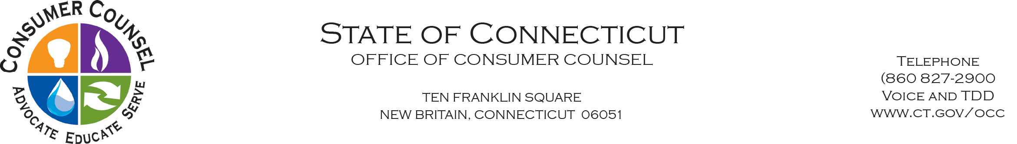

August 25, 2020

CONSUMER ALERT: CREDITS FOR STORM OUTAGES

From: Acting Consumer Counsel, Richard E. Sobolewski

Current rules require that customers of cable companies (Comcast, Cox, Charter, Altice/Optimum, Atlantic Broadband and Frontier) contact them in the event of storm and other service outages. Most companies need notification 30 days from the date of the outage. The Office of Consumer Counsel recommends that all customers who experienced a cable/broadband outage contact their providers as soon as possible in order to obtain the statutorily required credit or refund.

