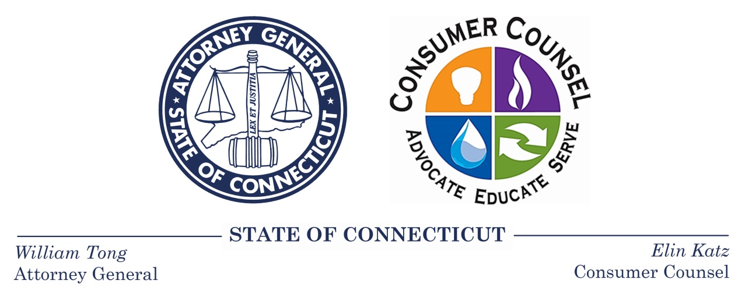

04/17/2019

ATTORNEY GENERAL TONG, CONSUMER COUNSEL KATZ
SUPPORT BAN OF “AUTO-RENEWALS” IN
THIRD-PARTY ELECTRIC SUPPLIER CONTRACTS

(Hartford, CT) –Attorney General William Tong and Consumer Counsel Elin Swanson Katz today urged legislators to pass the comprehensive suite of protections for existing and prospective customers of third-party electric suppliers in House Bill No. 7155, An Act Concerning Consumer Protections for Customers of Electric Suppliers, including a proposed ban of so-called “auto-renewals” of third-party supplier contracts with residential consumers.

House Bill No. 7155 proposes a requirement that residential customers must provide affirmative consent via a written or electronic signature to renew a contract with an electric supplier. If a residential customer does not provide affirmative consent to a supplier’s contract renewal, the bill requires the customer to be placed on the electric utility standard service rate when the contract expires.

"Electricity is far too expensive in Connecticut as it is, and no one should be tricked into paying even more. These changes will make it harder for bad actors to use teaser rates to lure and lock consumers into over-priced contracts. Putting an end to automatic renewals and enacting new safeguards against aggressive and misleading marketing are important steps to curb abuse in this industry," said Attorney General William Tong.

“One of the most common complaints I hear is that a consumer signed a contract with a low teaser rate for electricity, but then the contract automatically renewed with an escalating rate, sometimes for years at a time. The consumer then finds, when he or she remembers to check the electric bill, that the rate has shot up, and so has the electric bill, sometimes doubling or even tripling the teaser rate,” Consumer Counsel Katz said. “The affirmative consent feature safeguards consumers by requiring either their written or electronic signature to renew a contract with an electric supplier. This allows the savvy consumers who read their bills closely each month to ‘shop’ the market, while preventing those of us who don’t have the time, inclination, or expertise to follow electric rates that closely to avoid these auto-renewals that can costs hundreds or even thousands of dollars a year in excess electric costs. There is no downside to affirmative consent—even the most diligent consumer may miss a renewal notice when life gets hectic,” said Consumer Counsel Katz.

In addition to the affirmative consent provision, House Bill No. 7155 also serves to protect consumers from aggressive and misleading electric supplier marketing tactics by mandating that electric suppliers record their marketing interactions with consumers and perform criminal background checks on any marketer conducting door-to-door solicitations. Importantly, the bill also allows the Public Utilities Regulatory Authority to order electric suppliers to pay restitution to their customers upon findings of illegal electric supplier activity.

Consumer Counsel Katz and Attorney General Tong remind consumers that no one is required to shop for electricity. Residential consumers can always rely on the standard offer rates of Eversource Energy and United Illuminating, which are set through an open and competitive process that is overseen by several state agencies, and includes no mark-up or profit for the utilities. There is one price for every consumer, and it only changes twice a year, on January 1 and July 1.

OCC Contact: Elin Swanson Katz
Elin.Katz@ct.gov
860-614-8424

OAG Contact: Elizabeth Benton
Elizabeth.Benton@ct.gov
860-808-5324

