
Hemoglobin SC Disease (Hgb SC)
CONNECTICUT NEWBORN DIAGNOSIS AND TREATMENT NETWORK • JUNE 2019

KEY POINTS:
- Your baby’s newborn screen tells us that your baby may have Hgb S-C Disease.
- More tests are needed to tell if your baby has this disease.
- Your baby should see a special doctor called a hematologist by 3 months of age.
- If your baby has Hgb S-C disease, there are treatments that can help.
- Tell the doctor right away if your baby has a fever, swelling of the hands or feet or other problems.
What is newborn screening?
Newborn screening is a blood test to check for conditions that can be hidden at birth. Soon after birth, a nurse takes a few drops of blood from your baby’s heel. With newborn screening many conditions can be found and treated early.
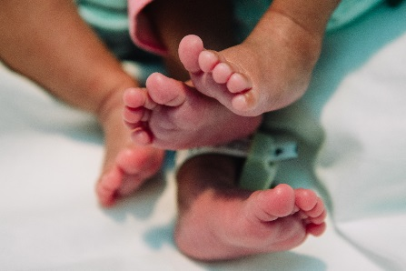
What does my baby’s newborn screen show?
Your baby’s newborn screen shows that your baby may have Hemoglobin S-C disease. Hemoglobin (Hgb) is a part of the red blood cell that carries oxygen. Usually a baby has two kinds of Hgb in the blood. These are Hgb F and Hgb A. Your baby has two kinds of Hemoglobin that we don’t usually see in the blood called Hgb S and Hgb C. Hgb S cells are shaped like a crescent moon and can block the flow of blood. Hgb S and Hgb C cells also break down very quickly. Your baby needs more tests to tell if he/she has Hgb S-C disease. It is important that your baby see a doctor who specializes in blood diseases called a hematologist by 3 months of age.
What is Hgb S-C disease?
Hgb S-C disease is a type of sickling disorder, but is usually milder than sickle cell (Hgb S-S) disease. Symptoms can start as early as a few months of age or later. Some children with Hgb S-C disease are in pretty good health, while others may be sicker. Children with Hgb S-C disease may:
- feel weak and tired | - have swelling in the hands and feet
- have severe pain at times | - have trouble breathing
- have more frequent illness | - have pale skin
- need blood transfusions | - cold hands and feet

Can Hgb S-C Disease be treated?
Yes, there are treatments that can help control the symptoms. If your baby does have Hgb S-C disease your doctor will tell you what the best treatment is for your baby. Extra fluids, medication and blood transfusions are possible treatments.
What causes Hgb S-C Disease?

Hgb S-C Disease is inherited. This means that both parents pass a gene to their baby. A gene is part of your body’s cells that stores instructions for the way our body grows and works. Genes come in pairs. You get one gene of each pair from a parent. Most of the times genes work the way they are supposed to. Sometimes there is a problem in one or more gene.
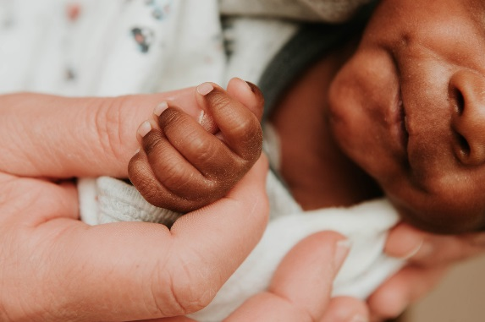
What happens next?
Your baby should see the hematologist by 3 months of age. This doctor will order more blood tests. Tell the doctor right away if your baby has a fever of over 101F (38C), swelling of the hands or feet or other problems. If tests show that your baby does have Hgb S-C disease, a doctor or nurse will tell you how to keep your baby healthy. Your baby may need to take medicine and will have to see the doctor for frequent check-ups. A genetic counselor can help you learn more about what Hgb S-C disease means for you and your family.
What if I still have questions?
You may feel overwhelmed during this process. If you have questions, please call the Connecticut Newborn Diagnosis and Treatment Network (the Network). To reach the Network, call 860-837-7870, Monday-Friday, 8:30am-4:30pm. Please go to the website www.babysfirsttest.org for more information about newborn screening and https://www.babysfirsttest.org/newborn-screening/conditions/s-c-disease for more information about Hgb S-C disease.

This fact sheet was written for information purposes only. It should not replace medical advice, diagnosis or treatment.

