CONNECTICUT NEWBORN DIAGNOSIS AND TREATMENT NETWORK • May 2020
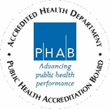
Congenital Adrenal Hyperplasia (CAH)
What is newborn screening?
KEY POINTS:
- Your baby’s newborn screen tells us that your baby may have congenital adrenal hyperplasia.
- More tests are needed to tell if your baby has this disorder.
- If treated early, children with congenital adrenal hyperplasia can have healthy growth and development.
- Tell your baby’s doctor if you baby has trouble feeding, is very sleepy or has other problems.
Newborn screening is a blood test to check for conditions that might be hidden at birth. To do the screening, a nurse takes a few drops of blood from your baby’s heel soon after birth. This blood sample is required for all newborn babies.
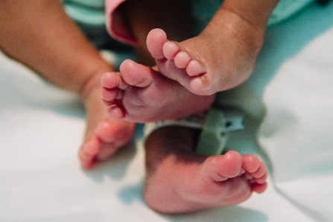
Newborn screening is not the same as diagnostic testing. The purpose of newborn screening is to find babies that need diagnostic testing.
Diagnostic testing will tell if a child has a condition.
What if my baby needs more testing?
If you are told that your baby needs follow-up testing, it does not mean that your baby has the disorder. An out of range result can occur because:
- the heel-stick blood sample was
  - too small.
  - collected too early.
  - collected too close to a feeding.
- the baby was born too early or had a low birth weight.
- the baby had certain treatments in the hospital.
Many babies who have follow up testing for congenital adrenal hyperplasia are healthy, and do not have this condition. However, out of range screening results CAN indicate a disorder, so it is important to follow your doctor’s advice & get your baby tested quickly so that treatment can start early if your baby does have congenital adrenal hyperplasia.

What is congenital adrenal hyperplasia?
Congenital adrenal hyperplasia (CAH) is a condition that affects how the body makes hormones. Hormones help the body work and grow. A person with CAH doesn’t make enough of a hormone called cortisol (also called the “stress hormone”). There are different types of CAH that can range from very mild to very severe. More testing can help determine which, if any, type of CAH your baby has.
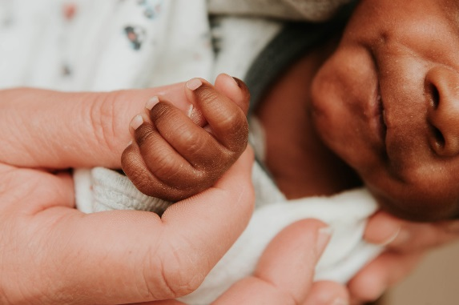
What does this mean?
Although CAH cannot be cured, it can be treated. The most common treatment for CAH are medications that replace the hormones that the body doesn’t make correctly. This will help to prevent health problems. If treated early, children with CAH can have healthy growth and development.

What happens next?
Your baby’s doctor may ask for your baby to have more tests. You will want to have these follow-up tests done as soon as possible. In some cases, you may be asked to visit a specialist called an endocrinologist. The endocrinologist will talk to you about the best plan for your baby.

What are the signs and symptoms of CAH?
If untreated, children with CAH may show signs of early puberty, rapid growth, or no symptoms at all. Some babies might have trouble feeding, unusual weight gain and be very sleepy. Girls with classical CAH may have male-looking genitalia. Tell your baby’s doctor if your baby has any of these problems.

What if I still have questions?
You may feel overwhelmed during this process. If you have questions, please call the Connecticut Newborn Diagnosis and Treatment Network (the Network). To reach the Network, call 860-837-7870, Monday-Friday, 8:30am-4:30pm. We also recommend the website www.babysfirsttest.org.

This fact sheet was written for information purposes only. It should not replace medical advice,
diagnosis or treatment.

