**Voices Forum**

2023

*Receiving Quality Care Through Goals, Preferences, and Priorities*

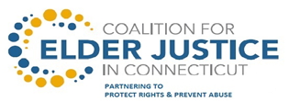 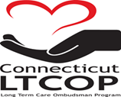 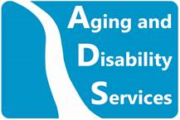

**Photographs and/or video will be taken at today's event**

By taking part in this event you grant the rights to use the images resulting from the photography/video filming for publicity or other purposes. This might include (but is not limited to), the right to use them in printed and online publicity and press releases.

If you do not wish to be photographed, please inform an event organizer.

**VOICES FORUM: Quality in Care**October 6 ,2023

**Agenda**

**Arrival and Registration**

**Pledge of Allegiance**

John Banks  
Council President from Sgt. John Levitow

**Welcome**

Mairead Painter

State Long Term Care Ombudsman

**Opening Remarks**

Amy Porter

Commissioner of the Department of Aging and Disability Services

**Presentation –** **Quality Surveys**

Julie Robison, Ph.D.

Professor of Medicine, UConn Center on Aging

**Presentation – Why have a Family Council?**

Liz Stern

Statewide Family Council Member

**Award Presentations**

Carol Rosenwald Spirit of Advocacy Award – The Late Quentin Williams

Brian Capshaw Rock Star Award - Toby Edelman

**Legislative Update**

Daniel Beem

Ombudsman Program

**Center for Medicare Advocacy -** Know your Medicare Rights

Judy Stein - Center for Medicare Advocacy; Executive Director/Attorney

**The importance of Resident Council**

John Balisciano

Statewide Coalition of Presidents of Resident Councils

**Resident and Staff Raffle**

**Lunch**

**Open Mic & Panel Discussion**

**Closing Remarks**

**Carol Rosenwald Spirit of Advocacy Award**

***“You Must Hold onto Your Ideals and Always Have the Courage to Speak Your Mind” ~ Carol Rosenwald***



**History of the VOICES Forum**

In September of 1996, nursing home resident and activist Carol Rosenwald, with assistance from the Ombudsman Program, began organizing residents across the state to advocate for improvements in the long-term care system.  Carol envisioned a time when the “VOICES” of nursing home residents could be heard “beyond the walls” of their facilities.  She became the founder of the Statewide Coalition of Resident Councils and the driving force behind the first “VOICES” Forum in 1997.  As a large group of voting constituents, residents were able to speak directly with political leaders and public officials about important issues affecting their quality of life.

VOICES 2019 marks the 26th anniversary of Carol’s vision and of this historic event.  Our heartfelt thanks to the many courageous residents who have attended VOICES over the years and to all of you attending today who inspire systems change in long term care.  You have our deepest admiration and respect.

~The Long-Term Care Ombudsman Program

**This year we are pleased to award the**

**Carol Rosenwald Spirit of Advocacy Award**

**to**

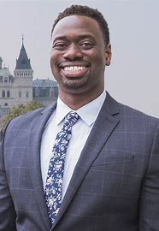

**Quentin Williams – The late State Representative**

The first-ever Black State Representative for the City of Middletown, CT and previous House chair of the Aging Committee, Quentin Williamsworked tirelessly and inspired us to create a more equitable future. Quentin was instrumental in leading the debate and the ultimate passage of several significant bills related to long term care residents. This included strengthening the bill of rights for long-term care residents and authorizing the use of resident technology for virtual visitation and virtual monitoring during the COVID-19 Pandemic. Quentin had taken the Oath of Office for his third consecutive term just before his passing. At age 39 he touched many more lives with his optimism, passion, and joy than most people twice his age. His electric smile was a source of encouragement for all those who knew and loved him. He died unexpectedly on Thursday, January 5, 2023

**Brian Capshaw Rock Star Award**

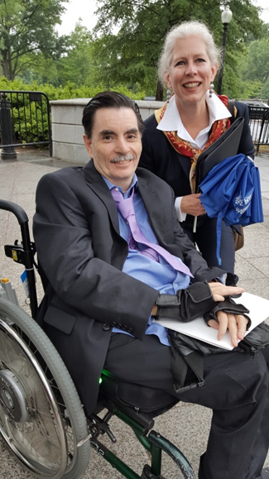

The Coalition of Presidents of Resident Councils and the Long-Term Care Ombudsman Program are pleased to announce the Brian Capshaw annually award recipient. Brian is remembered for his incredible advocacy both in Connecticut and at the national level. In 2012, Brian participated in the Consumer Voice Conference in Washington, DC. He represented Connecticut nursing home residents with a strong voice and with the incredible advocacy that only one who has “walked the walk” can bring to the conversation. He was the resident representative on the Long-Term Care Advisory Council, he testified at countless hearings and he went door to door at the capitol talking with legislators about all the issues so important to quality care and services for nursing home residents: improved staffing levels, video monitoring, personal needs allowance, to name just a few. Brian also worked on national advocacy: he was appointed to be the Chair of the Leadership Council of the Consumer Voice, he was interviewed numerous times by the national media and participated in a wide variety of state and national workgroups. Brian was invited to the White House to participate in the 2015 White House Conference on Aging.

Brian loved sports, his family and friends, getting into his van to meet friends for concerts and various activities. He thoroughly enjoyed his rock music! Brian, in every fashion, was an inspiration and a joy to all who knew and admired him. We miss him dearly.

**This year we are pleased to award the**

**4th annual Brian Capshaw Rock Star Award**

**to**

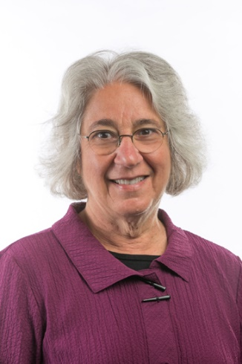

**Toby Edelman**

**Senior Policy Attorney**

**Center for Medicare Advocacy**

Toby S. Edelman has been representing older people in long-term care facilities since 1977. As a Senior Policy Attorney with the Center for Medicare Advocacy since January 2000, Ms. Edelman provides training, research, policy analysis, consultation, and litigation support relating to nursing homes and other long-term care facilities. Under two grants from the Commonwealth Fund, she evaluated the federal nursing home survey and enforcement system and its impact on state activities and provided technical assistance to states on effective enforcement practices. In cooperation with the Centers for Medicare & Medicaid Services, she recently completed a Commonwealth Fund project to evaluate seven states' deficiency citations for misuse of antipsychotic drugs. Since September 1999, she has written a monthly newsletter on nursing home enforcement issues.

Ms. Edelman was the lead attorney for a statewide class of nursing facility residents who successfully challenged the state of California's refusal to implement the federal Nursing Home Reform Law (Valdivia v. California Department of Health Services, Civ. No. S-90-1226 EJG (E.D. Calif. 1993). As a beneficiary representative, Ms. Edelman has testified before Congress and served on federal task forces, technical expert panels, and working groups on nursing home issues.

Ms. Edelman received a B.A., Magna cum Laude, from Barnard College (1968), an Ed.M. from the Harvard Graduate School of Education (1969), and a J.D. from the Georgetown University Law Center (1974). Ms. Edelman is a member of the Washington, DC Bar.

**Executive Board Members**

E-board Member Name Facility & Contact Information

|  |  |
| --- | --- |
| John Balisciano Jr.  President | Hewitt Health and Rehab  203-924-6118  [john.balisciano196593@aol.com](mailto:john.balisciano196593@aol.com) |
| Susan Bilansky | Hebrew Home  860-906-4292  SBilansky45@gmail.com |
| Martha Leland | Touchpoints of Manchester  860-432-7279  [meleland5@gmail.com](mailto:meleland5@gmail.com) |
| Thomas Dorman | Amberwoods of Farmington  860-294-6494  [trdorman0783@gmail.com](mailto:trdorman0783@gmail.com) |
| Jeanette Sullivan-Martinez | Pendleton Healthcare  860-333-3411  [Jennie.Martinez518@gmail.com](mailto:Jennie.Martinez518@gmail.com) |

The E-Board members are open to other resident councils reaching out to them for information or to join the greater coalition of resident council presidents.

To our Resident Advocates who selflessly volunteer their time advocating on behalf of nursing home residents.

Thank You!

|  |  |
| --- | --- |
| **Volunteer** | **Facility** |
| Ann Marie Fumo | Middlesex Healthcare Center |
| Barbara Clerkin | Apple Rehab Old Saybrook |
| Brenda Fife | Geer Nursing and Rehabilitation Center |
| Colleen Mcdermott | Touchpoints of Farmington |
| Deb Ciofi | Bayview Health Care Center |
| Doreen Near | Mystic Healthcare |
| Jennifer Glick | Chelsea Place |
| Joyce Werden | Norwich Sub-Acute (Norwichtown) |
| Karen Haabestad | Apple Rehab Mystic |
| Kevin Place | Candlewood Valley Nursing Home |
| Linda Rosen | Governor’s House |
| Richard Steele | Beechwood |
| Susan Williams | Touchpoints at Chestnut |
| Vy Pham | Civita of Newington |

**Voices Forum 2023 Post Event Survey**

**Anyone can respond, Anonymous**

**Scan the QR code to Vote or go to:** [**https://forms.office.com/g/qaaZNRAWn1**](https://forms.office.com/g/qaaZNRAWn1)

[](https://www.google.com/imgres?imgurl=https://ih1.redbubble.net/image.312670318.7369/st,small,215x235-pad,210x230,f8f8f8.u2.jpg&imgrefurl=https://www.redbubble.com/shop/lgbt%2Bally%2Bstickers&docid=tiLHG2hJ2QvBeM&tbnid=bdnVy5blDvkhDM:&vet=10ahUKEwiC6obSk6jkAhUITN8KHck_BYYQMwiBASgUMBQ..i&w=210&h=230&bih=861&biw=1280&q=LGBT%20Ally%20symbol&ved=0ahUKEwiC6obSk6jkAhUITN8KHck_BYYQMwiBASgUMBQ&iact=mrc&uact=8)

**For more information or to contact the**

**Long-Term Care Ombudsman Program**

You can also e-mail us:  [ltcop@ct.gov](mailto:ltcop@ct.gov)

Follow us on Facebook: [**www.facebook.com/CTLTCOP**](http://www.facebook.com/CTLTCOP)

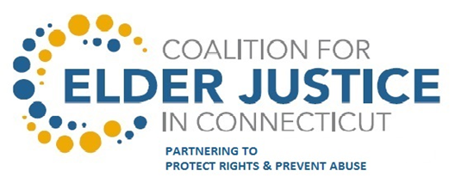

**Mission**

Coalesce and leverage a multi-disciplinary, statewide group of private and public  
stakeholders to prevent elder abuse and protect the rights, independence, security, and  
well-being of vulnerable elders.

**Our Coalition**

The Coalition of Elder Justice in CT ~ A multi-disciplinary, statewide group of private and public stakeholders working together to prevent elder abuse and protect the rights, independence, security, and well-being of vulnerable elders.”

**Our History**

The Coalition for Elder Justice in CT was formed by the State Department on Aging in 2013 to lead and convene public and private stakeholders addressing elder justice issues in Connecticut. Governor Dannel Malloy recognized the Coalition and authorized the active participation by various state departments to collaborate and protect elders from multiple forms of elder abuse as illustrated in Executive Order 42.  Since that time, the Coalition has hosted annual Seminars and Coordinating Council sessions and our partners have increased two-fold. A number of Action Teams have also been working on such issues as Financial Exploitation, Bank and Faith-Based training, and partnering with AARP Fraud Watch. With the recent award of an Administration of Community Living grant, support will be provided for Conservator Web-based Training, Law Enforcement training, and Elder Abuse Awareness.

**Steering Committee**

While the day to day coordination and operations are executed by Co-Chairs, presently State Unit on Aging lead staff, the Steering Committee is comprised of five key, member organizations with distinct expertise in elder abuse. Together they provide support, guidance and oversight of progress on behalf of the Coalition.

**Coalition Members**

The Coalition is a multidisciplinary, statewide network of agencies and organizations that are partnering to achieve the vision and goals of the Coalition. Membership is open to all interested stakeholders at no cost. Members receive information and updates and have opportunities to attend seminars and the annual meetings and participate in Action Teams.

Interested in joining the Coalition

Please Visit

[**http://elderjusticect.org/**](http://elderjusticect.org/)

Click on Join the Coalition tab and fill out the membership form.

**Coalition For Elder Justice In Connecticut**

Co-Chairs

Lara Stauning, Staff Attorney, Aging and Disability Services, State Unit on Aging

Mairead Painter, State Long-Term Care Ombudsman

