[](https://www.youtube.com/channel/UCGjJOsAJoTztnKyusSwnXeQ)

**State of Connecticut Job Openings   
Follow Us…**

**BY SERVING YOUR STATE**

https://portal.ct.gov/DAS



stateofctjobs



ctstatejobs



ct das



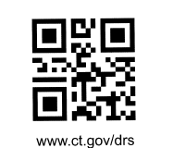**Department of Revenue Services**