ITEM #1220027A – construction Signs

[This is a sample special provision that should be revised to be specific to each project.
The Bipartisan Infrastructure Law (BIL) signs are used on projects with roadway impacts where the BIL project sign will be visible from a public roadway The Bipartisan Infrastructure Law funding signs are not required where the installation is not practical such as:
- Various location projects with multiple sites (typically greater than 5 sites)
- Projects where work at a site will be short duration (typically less than 7 days)
- Projects where the sign installation is not feasible such as sites where:
- there is limited ROW
- the sign would restrict sight lines
- there are other physical constraints
The above is a guide and each project should be reviewed by the designer.
If the signs are not feasible or practical based on the above, this special provision should not be included in the Project.]

Section 12.20 is supplemented and amended as follows:

Article 12.20.01 – Description:

Add the following:

The Contractor shall also furnish, install, maintain, and remove Bipartisan Infrastructure Law project signs. The Bipartisan Infrastructure Law project signs shall be of the details, colors and materials as shown on the attached detail sheet.

The sign legend for this Project shall include the U.S. Department of Transportation pictograph on the lower right side of the sign with the legend [insert Project funding source: Federal Highway Administration, FTA, FRA, or NHTSA.]

Article 12.20.03 — Construction Methods:

Add the following:

The Contractor shall install the Bipartisan Infrastructure Law (BIL) project signs prior to initiating construction.

[Please revise the paragraph for sign locations if needed as applicable to the Project.]
The Contractor shall install BIL project sign 80-5957 on each major roadway approach to the construction Site in advance of the Project limit(s).
The sign detail is included and is also available at 80-5957.

The Contractor shall maintain the BIL project signs for the entire duration of the Project. The Contractor shall relocate the BIL project signs during construction as needed and shall remove the signs after construction work is completed.

Article 12.20.05 – Basis of Payment:

Add the following:

The price shall also include furnishing, installing, maintaining, relocating, and removing the Bipartisan Infrastructure Law project signs and sign posts and all hardware, materials, and labor incidental thereto.
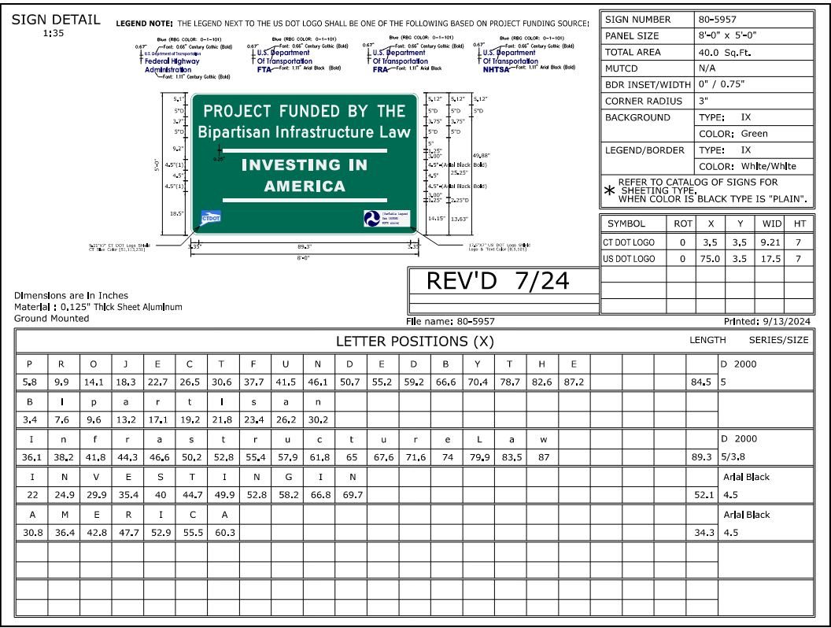

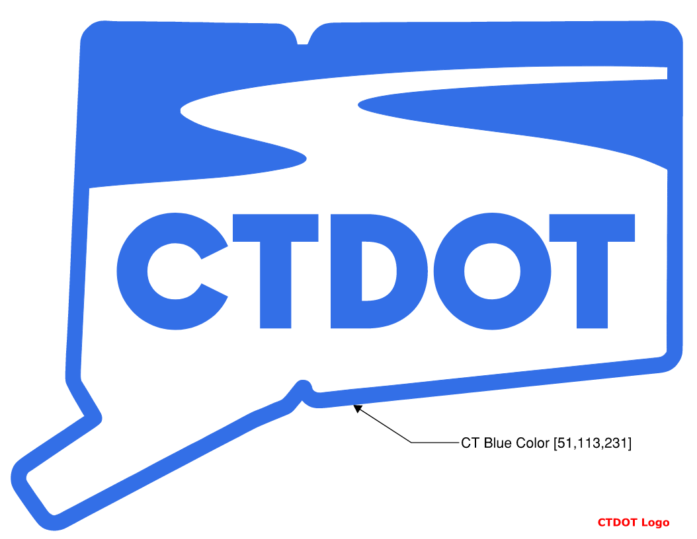
Link to .dgn file: New_CTDOT_Logos.dgn

Link to .dgn file: USDOT_logo.dgn

