Photolog Equipment Calibration Site Requirements
CTDOT Data Quality Management Plan
April 17, 2019

Background

Under Federal Code 23 CFR 490.310(c), State DOT’s are required to develop a Data Quality Management Plan (DQMP), which defines new standards for acceptable levels for of data quality and describes how the collection process will ensure this level of quality in its deliverables and processes. In addition, the Plan further details staff responsibilities, methods and procedures for ensuring quality data practices throughout our field collection and the need for the calibration and verification of the survey and profiling equipment to be used for the collection of pavement condition data. In August 2018, the Department received final approval from FHWA on its new DQMP.

To establish the verification and control sites, extensive research evaluating historical data, reviewing the State road network and other alternate sites, such as rest areas or other off network locations, to find an acceptable location for use. The Consumer Reports Test Track in Colchester was one of the sites identified. An initial meeting was held with the CR staff to discuss the Photolog verification and control site needs and review the Consumer Reports Test Track facility. Further discussion resulted in an agreement to provide a copy of the Photolog data collected back to Consumer Reports for their internal use. The ARAN Vans then performing an initial data collection in the areas of interest to verify if the current pavement conditions would be favorable. Results of the data confirmed that the CR Test Track Facility would provide for a suitable location.

The IRI, Longitudinal & Transverse Profiles and Rut Depth verification control and profile sections would use a 1500ft length of track located at the northern end of the Main Track section as shown in Figure #2 below. To make best use of this area the individual layouts would be super-imposed on top of each other as shown in Figure #3 below.

Mark out will consist of temporary paint marks placed on the right hand yellow lane line, centerline of right and left wheelpath and left hand dashed lane line, and various temporary chalk mark out lines as necessary.

Control Site Location
Consumer Reports Test Track, Hall Kilburne Road, Colchester, CT.
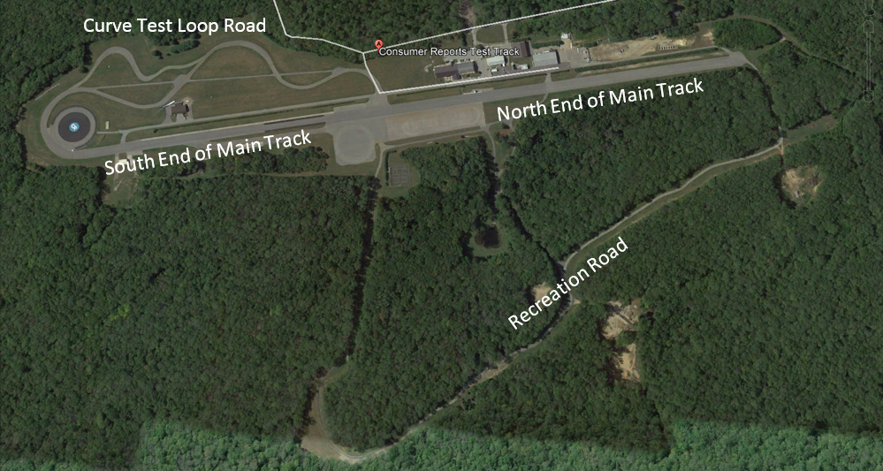
Figure #1 – Consumer Reports Test Track Facility Detail

Detail of Primary Control Site Location
1500ft Section at North End of Main Track
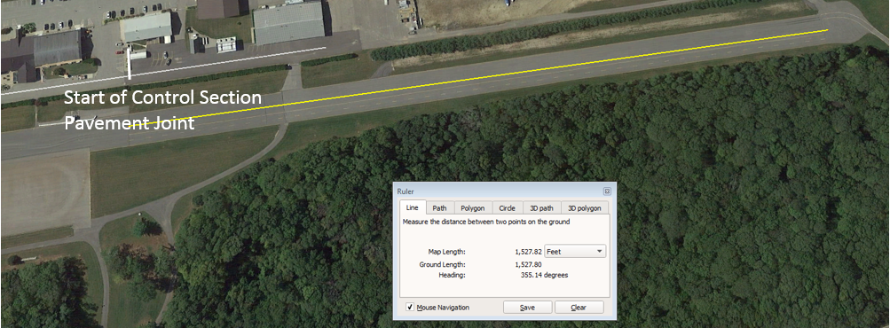
Start of Control Section Pavement Joint
Figure #2 –Control Site Location used for IRI, Longitudinal & Transverse Profiles and Rut Depth

Individual requirements for the IRI, Longitudinal & Transverse Profiles and Rut Depth verification control and profile sections are further detailed on pages following Figure #3.

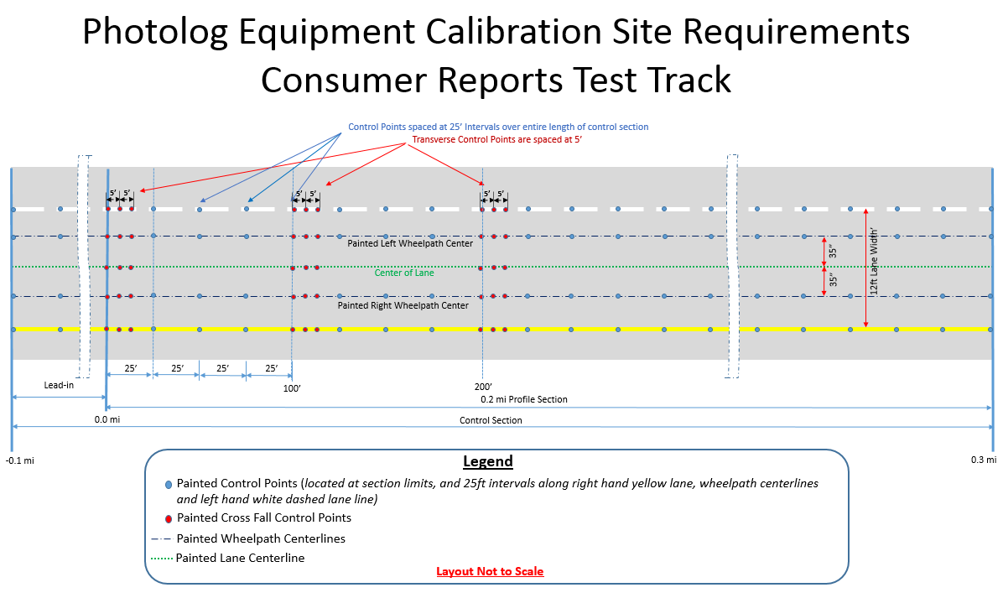
Figure #3 Composite of Control and Verification Layouts

IRI and Longitudinal Profile Verification Section

Layout
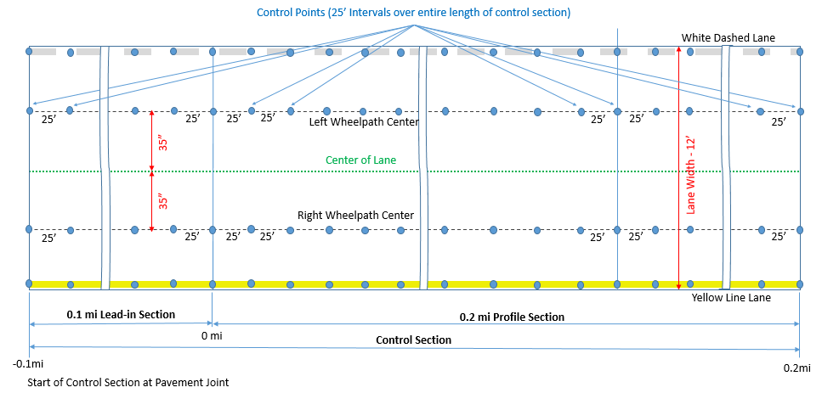

Site Length – 0.3 mi (0.2 mi profiling section and 0.1 mi lead in)

Layout Procedures
Step 1. Mark section limits as shown above.
Step 2. Mark control points (located 25 ft apart on each wheelpath centerline) as shown.
Step 3. Mark wheelpath centerlines as shown.
- Use 100-ft surveyor tape or geodetic total station for measuring distances.
- Use visible paint markings for measurement lines, centerlines and control points.

Site Requirements

Test Speed  (mi/hr) | # of sites | Site Length* | Longitudinal Grade** | Cross Slope | Expected Ride Quality/(Average MRI per 0.1 lane-mile | Total Cracking length in 0.1 lane-miles
45-65 | 1 | 0.2 mi+ 0.1mi lead-in | <2% | <3% | 90 to 120 in/mi | <300 ft
25-40*** | 1 | 0.2 mi+ 0.1mi lead-in | <2% | <3% | 100 to 150 in/mi | <300 ft

*According to ASTM E 950 for ARAN systems
** No curves or super-elevations
*** ARAN Measuring speed must not be lower than 25 mph

Survey Procedures and Equipment
Step 1. Using SSI CS8800 profiler, survey continuous profile with 0.5-in interval in each
Wheelpath through the whole length of the profiling section, as well as for at least 150 ft of lead-in and 150ft of lead out, in accordance with ASTM E2133-03 and manufacturer’s instructions. Repeat survey three times.
Step 2. Save profile data from Steps 1 and 2 in *.PRO format for further use in ProVal software.
Step 3. Use the above data to determine precision, repeatability, and reproducibility of SSI
CS8800 profiler

Transverse Profile Measurements Verification Section

Layout
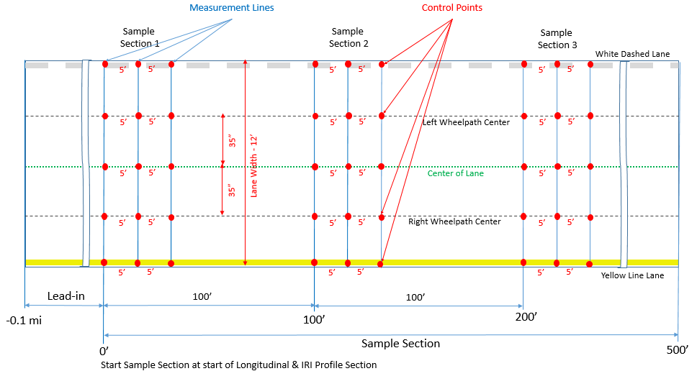

Layout Procedures
Step 1. Mark measurement lines (3 lines located 5 ft. apart) for each sample section (located
100 ft. apart) as shown.
Step 2. Mark control points (located in the intersections of each measurement line with white
line, yellow line, wheelpath centerlines and centerline of the lane) as shown above.
- Use metal surveyor tape or total station to layout the transverse measurement lines and control points.
- Use visible paint markings for measurement lines and control points.

Site Requirements

Number of sites | Site Length | CTDOT Drainage Index | Absolute Value of Cross Slope | Absolute Value of Longitudinal Grade
1 | 500 ft | 3-5 | <3% | <2%

Survey Procedures and Equipment
On each Sample Section, perform the following procedure:
Step 1. Using automated level and rod or Straight Edge with Leica Disto D8, survey profile in
each measurement line in accordance with ASTM E1364-95. Note that the direction of measurement is transverse to the direction of travel.

Step 2. Using SSI CS8800 profiler, survey continuous profile with 0.5-in interval in each
Measurement line in accordance with ASTM E2133-03 and manufacturer’s instructions. Repeat survey three times.

Step 3. Save profile data from Steps 1 and 2 in tabulated format (longitudinal offset, transverse
offset, and elevation) for further analyses.

Step 4. Use the above data to determine precision, accuracy (with respect to manual method),
and reproducibility of SSI CS880 profiler in accordance with Section 2.6.2 of this Manual

Rut Depth Measurement Verification Section

Layout
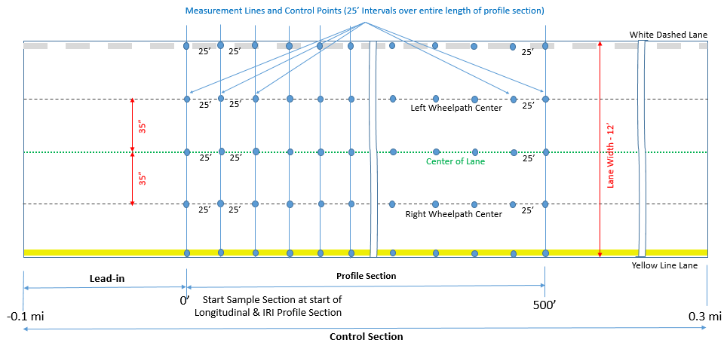

Layout Procedures
Step 1. Mark wheelpath centerlines as shown above.
Step 2. Mark control points (located in the intersections of each measurement line with white
line, yellow line, wheelpath centerlines and centerline of the lane) as shown above.
Step 3. Mark transverse measurement lines (located 25 ft. apart over the whole length of the
profiling section) as shown above.
- Use surveyor tape or total station to layout the transverse measurement lines and control points.
- Use visible paint markings for measurement lines and for control points.

Site Requirements

Number of sites | Site Length | HPMS Rutting Rating | CTDOT Distortion Index | Average Rut Depth ([LWP_RUT+RWP_RUT]/2) per 0.1 lane-mile
1 | 500 ft | Fair | 4.0-6.0 | 0.25-0.5 in

Survey Procedures and Equipment

Step 1. Using SSI CS8800 profiler, survey continuous transverse profiles on each measurement
line in accordance with ASTM E2133-03 and manufacturer’s instructions. Repeat survey three times.

Step 2. Step 3. For each profile measured by SSI CS8800, calculate Maximum rut depth in each
wheelpath and store the data in accordance with AASHTO PP69-14.

Step 4. Use the above data to determine precision, repeatability, and reproducibility of SSI
CS880 profiler.

JRCP/Faulting Verification Section

Due to the very limited amount of Jointed Reinforced Concrete Pavement (JRCP) in Connecticut that contains any faulting, finding a validation site on the State Network is not possible. CTDOT is planning to use a section of the Consumer Reports Test Track, (henceforth called a JRCP verification section) in lieu of using the State network as shown below in Figure #3.

Location
Consumer Report Test Track - 1200ft Section of Concrete at South End of Main Track
(No safe or viable site alternatives could be found on the state road network)
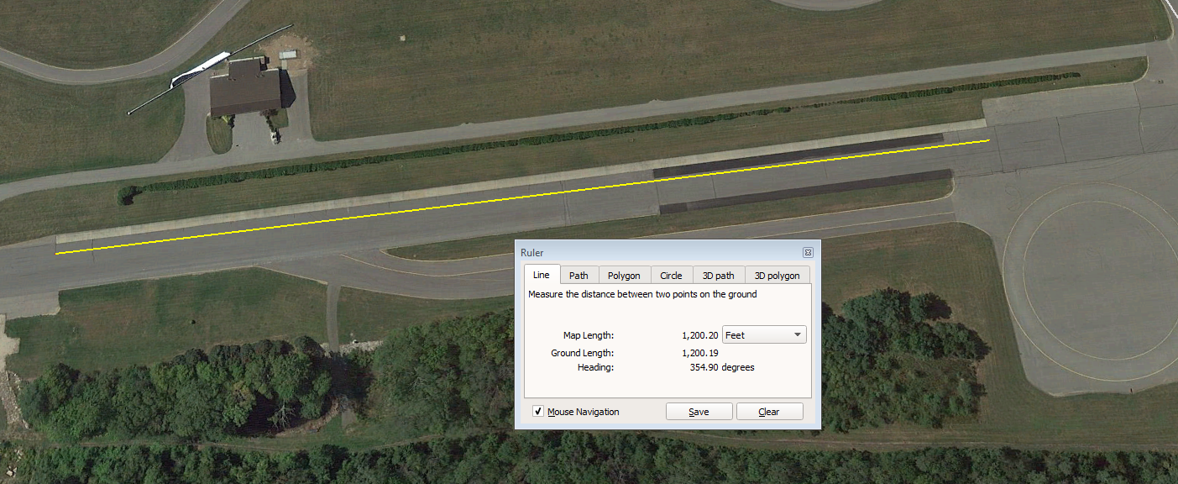
Figure #3 - Control Site Location for Jointed Reinforced Concrete Pavement (JRCP)/Faulting
Site Length – 1200ft.

Site Requirements

Number of sites | Surface Type | Site Length** | Transverse Joint Spacing*** | HPMS Condition | HPMS Average Faulting per lane-mile**** | CTDOT PMIS Maximum Faulting in Right Wheelpath per 0.1 lane-mile
1 | Jointed Concrete Pavement | 1 mile* | 15-40 ft | Fair | 0.1-0.15 in | <2%

*No partial-depth repairs (patching) on site
** Limited JCRP exist in CT at less than .1% of the state network. As an alternative, the CR Test Track represents the next best viable option statewide for verification and control.
*** Joint spacing as measured on site
****In accordance with AASHT R36-13. The Average Faulting is calculated from the automated measurements of
longitude profile in the right wheelpath.

Survey Procedures and Equipment

Before conducting the survey of a validation site:
- Ensure that DMI, other sensors and lasers, installed on ARAN vans, are calibrated in accordance with manufacturer guidelines.
- Ensure that ARAN LCMS conforms to ASTM E1656 (the latest version).
- Perform diagnostics of DMI, GPS, Grade, LCMS, POS LV, Roughness, and Video systems.
While collecting data on a validation site:
- Follow pre-determined collection procedure (with or without Auto Start) in accordance with
Section 9.2 of the ARAN User Manual 2.0.
- Follow the wheelpath center as close as possible to ensure both inner and outer lane markings are visible on downward pavement images.
- Ensure constant speed (not less than 25 mi/hr) within validation site limits.
- Avoid weaving and braking within validation site limits.

Cracking Measurement Verification Section

CTDOT Chosen Site - Route 354 EB in Deep River, Mile Points: 3.7- 4.2

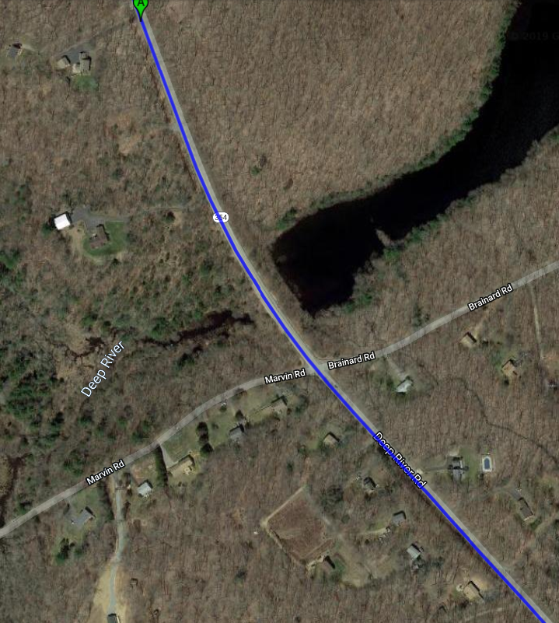

Site Requirements

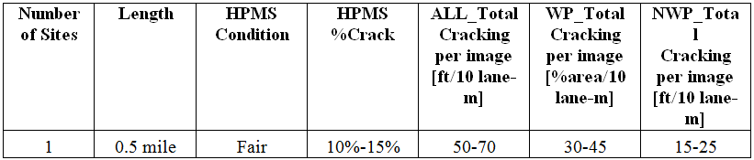

Survey Procedures and Equipment

Office Manual Distress Survey
Step1. Collect pavement images from the survey section with ARAN Vans using LCMS System in
accordance with AASHTO PP 68-14.

Step 2. Use WiseCrax software in manual mode to identify and rate cracks.
- Note 1: An experienced Distress Rater shall perform this step manually.
- Note 2: The lane zone dimensions setting should match the requirements of the HPMS guide (also see Figure 2.3.4.1)
- Note 3: Crack detection settings including severity thresholds should be finalized and approved by CTDOT’s Pavement Management Unit (PMU) prior performing Step 2.
Step 3. Store cracking survey data in tabulated form in accordance with AASHTO R 55-10.
Step 4. Use the above data to determine precision, accuracy (with respect to field manual or
ARAN distress surveys), and reproducibility of office manual distress survey.

