DEPARTMENT OF HOUSING

PROJECT SIGN – CDBG Funds

8’-0”

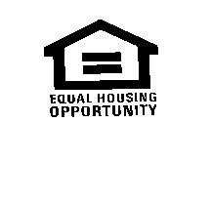
4’-0”
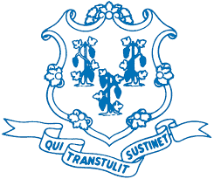
NAME OF THE PROJECT

NAME OF THE SPONSOR /DEVELOPER

Constructed in cooperation with the

STATE OF CONNECTICUT
__ (insert full name) __, GOVERNOR

Department of Housing
__ (insert full name) ___, Commissioner

U.S. Department of Housing and Urban Development (HUD)

and the

Name of Town/City
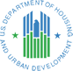
Name of Chief Elected Official and title

Name of Architect Name of General Contractor

SIGN PANEL: ¾” MDO-EXT-APA PLYWOOD SUPPORTED WITH (2) 4X4 TREATED WOOD COLUMNS AND SECURED 4’ INTO GRADE. TOP OF SIGN AT 8’-0” ABOVE GRADE.

COLORS: ALL LETTERS AND SYMBOLS ARE TO BE ROYAL BLUE. THE BACKGROUND WILL BE WHITE ENAMEL. BACK OF PLYWOOD AND SUPPORT STRUCTURE SHALL BE PAINTED MATTE BLACK.

TYPEFACE: HELVETICA MEDIUM

LOCATION: SIGN MUST BE LOCATED TO BE CLEARLY VISIBLE TO THE PUBLIC.

TIMING: INSTALL AT THE START OF CONSTRUCTION AND REMOVE AT CONSTRUCTION COMPLETION.

STATE SEAL & LOGO: ATTACHED

