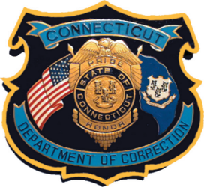
Video Consent and Release Form

Without expectation of compensation or other remuneration, now or in the future, I hereby give my consent to the Connecticut Department of Correction its affiliates and agents, to use my image and likeness and/or any interview statements from me in its public service announcements, publications, or other media activities (including the Internet).
This consent includes, but is not limited to:
Permission to interview, film, photograph, tape, or otherwise make a video reproduction of me and/or record my voice; Permission to use my name; and Permission to use quotes from the interview(s) (or excerpts of such quotes), the film, photograph(s), tape(s) or reproduction(s) of me, and/or recording of my voice, in part or in whole, in its publications or electronic media (including the Internet), for educational and awareness purposes.
This consent is given in perpetuity, and does not require prior approval by me.

Name (print) : ______________________________________

Signature: _________________________________________
Date: ____________________

