
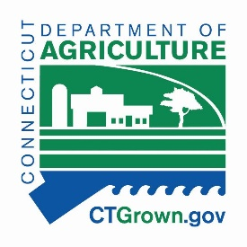
BRYAN P. HURLBURT
Commissioner

DEIDRE S. GIFFORD, MD, MPH
Commissioner

Farmers Markets and Direct Marketing Farmers SNAP Wireless Equipment Grant
Letter of Intent cont.

Date: ________________________ FNS # (seven digits): ______________________________

Name of Entity: __________________________________________________________________________

Location (full address):_____________________________________________________________________

Type of Market (circle one): Farmers’ Market Direct Marketing Farmer

Contact name (printed/typed): ________________________________________________________________

Phone: _______________________________ Email: ____________________________________________

Signature (typed signature allowed): __________________________________________________________

Do you already accept SNAP?: Yes No
  - If yes, do you have functioning wireless equipment?: Yes No

  - Do you already have a POS device that accepts credit and/or debit cards? Yes No

2020 Season start date ___________________ Season end date ______________________

2021 Season start date (aprox.) ___________________ Season end date (aprox.)_________________

I realize additional information will be required to complete the application process prior to obtaining a
POS SNAP device.

Incomplete request forms will not be processed.

Submit signed and completed forms to Crystal Morris-Crenshaw, Crystal.Morris@ct.gov, with the Connecticut Department of Agriculture. Questions not addressed in the FAQ’s can be directed to Jaime Smith at the Connecticut Department of Agriculture, Jaime.Smith@ct.gov or Kristin Krawetzky at the Connecticut Department of Social Services, Kristin.Krawetzky@ct.gov.

The CT DSS and DoAg are not responsible for misdirected emails.

