Coping Skills Post Test

- What is good self-esteem?
  - Feeling good about yourself
  - Listening to others
  - Hating yourself
  - Wanting to harm yourself or others

- Which of the following is the definition of stress?
  - A simple situation with no conflict
  - Feelings of strain or tension from a difficult situation
  - Spending time with friends
  - Going to school daily

- What are ‘triggers’ and what some personal triggers are? __________________________
________________________________________________________________________________________________________________________________________________________________________________________________________________________

- True or False: Signs of stress can be different for each person and can affect them both physically and emotionally.

- Please write the name of the emotion under the correct picture:
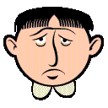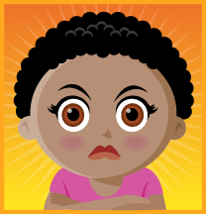
_______________ __________ _________ ___________

- Who are three supports that can help you when you need help?
  - _____________________
  - _____________________
  - _____________________

- Which of the following is NOT a positive coping strategy?
  - Screaming into a pillow
  - Going for a walk/run
  - Hitting someone who made you upset
  - Talking out the problem with a support

- True or False: exercise is not a good way to help prevent stress and often causes more stress.

- Your friends showed up an hour late to go out to dinner. Which is an appropriate way to find out why they were late?
  - Figure you got stood up
  - Scream at your friends when they get there
  - Don’t say anything
  - Ask them why they were an hour late

- Explain how you could correctly express a negative emotion you felt recently? ________________________________________________________________________________________________________________________________________________________________________________________________________________________

- Which of the following would NOT be a negative coping strategy:
  - Hitting another person
  - Destruction of property
  - Talking out the problem with the person
  - Abusing drugs or alcohol

- Name someone who would give you advice and how would you get this advice? ________________________________________________________________________________________________________________________________________________________________________________________________________________________

