Coping Skills Post Test
Answer Key

- What is good self-esteem?
  - Feeling good about yourself
  - Listening to others
  - Hating yourself
  - Wanting to harm yourself or others

- Which of the following is the definition of stress?
  - A simple situation with no conflict
  - Feelings of strain or tension from a difficult situation
  - Spending time with friends
  - Going to school daily

- What are ‘triggers’ and what some personal triggers are? Triggers are anything which can cause you distress. It could be a song, a game or even something emotionally like losing or being alone. Individual should state at least two personal triggers.

- True or False: Signs of stress can be different for each person and can affect them both physically and emotionally.

- Please write the name of the emotion under the correct picture:
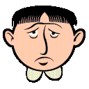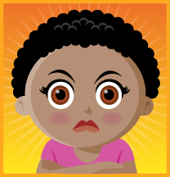
Happy Sad Angry Confused

- Who are three supports that can help you when you need help?
  - Parent
  - Clergy
  - Mentor

- Which of the following is NOT a positive coping strategy?
  - Screaming into a pillow
  - Going for a walk/run
  - Hitting someone who made you upset
  - Talking out the problem with a support

- True or False: exercise is not a good way to help prevent stress and often causes more stress.

- Your friends showed up an hour late to go out to dinner. Which is an appropriate way to find out why they were late?
  - Figure you got stood up
  - Scream at your friends when they get there
  - Don’t say anything
  - Ask them why they were an hour late

- Explain how you could correctly express a negative emotion you felt recently? Depending on the emotion the individual should give a socially appropriate way to express the emotion

- Which of the following would NOT be a negative coping strategy:
  - Hitting another person
  - Destruction of property
  - Talking out the problem with the person
  - Abusing drugs or alcohol

- Name someone who would give you advice and how would you get this advice? Individual should name someone they can trust for advice. One way to ask for advice would be “ Hi Adam. How are you? I was wondering if you could help me with a problem I’m having.”

